|  |
| --- |
| 2013/14 |

**Appendix 'A'**

Lancashire County Pension Fund

Annual Report

2013/14

**Lancashire County Pension Fund**

**Annual Report 2013/14**

**Contents**

|  |  |  |
| --- | --- | --- |
| **Section** | **Description** | **Page** |
|  |  |  |
| **A** | **Management Structure** | **3** |
|  |  |  |
| **B** | **Foreword by the Chair of the Pension Fund Committee and Treasurer to the Pension Fund** | **4** |
|  |  |  |
| **C** | **Governance of the Fund** | **6** |
|  |  |  |
| **D** | **Administration of the Fund** | **9** |
|  |  |  |
| **E** | **Knowledge and Skills Framework** | **14** |
|  |  |  |
| **F** | **Investment Policy and Performance** | **16** |
|  |  |  |
| **G** | **Accounts of the Fund** | **30** |
|  |  |  |
| **H** | **Actuarial Valuation** | **66** |
|  |  |  |
| **I** | **Contacts** | **74** |
|  |  |  |
|  |  |  |
|  |  |  |

|  |  |  |  |  |  |  |  |  |  |
| --- | --- | --- | --- | --- | --- | --- | --- | --- | --- |
| 1. **Management Structure**  |  |  |  | | --- | --- | --- | | **Management Structure as at**  **31 March 2014** | **Administering Authority**  Lancashire County Council |  | |  |  |  | | **Pension Fund Committee**  2013/14 (as at March 2014)  **Lancashire County Council**  L Beavers  D Borrow  M Brindle  T Burns (Chair)  G Dowding  J Gibson  J Oakes  M Parkinson (Deputy Chair)  A Schofield  K Sedgewick  D Stansfield  V Taylor  D Westley  **Blackburn with Darwen**  **Borough Council**  Vacant  **Blackpool Borough Council**  M Smith  **Lancashire District Councils**  P Leadbetter  I Grant  **Co-opted Member representing Trade Unions**  R P Harvey  R Whittle  **Co-opted Member representing HE/FE Establishments**  J McCann | **Fund Managers**  AGF  Baillie Gifford & Co  Capital Dynamics  Knight Frank  Mellon Transition Management  MFS International (UK) Ltd  Morgan Stanley Investment  Management  NGAM UK Ltd  Robeco Institutional Asset  Management  In-House  **Custodian**  Northern Trust  **Independent Investment Advisers**  E Lambert  N Mills  **Treasurer to the Lancashire County Pension Fund**  G Kilpatrick CPFA  **Actuary**  Mercer  **Auditor**  Grant Thornton | **Property Solicitors**  Pinsent Masons  DWF  **Independent Property Valuer**  Cushman & Wakefield  **Corporate Governance Adviser**  PIRC  **Performance Measurement**  Northern Trust  **AVC Providers**  Prudential  Equitable Life  **Legal Advisors (other than property)**  In-House  MacFarlanes  Eversheds  Clifford Chance  Allen and Overy  Taylor Wessing  Addleshaw Goddard  **Bankers**  National Westminster | |

1. **Foreword by the Chair of the Pension Fund Committee and Treasurer to the Pension Fund**

Welcome to the Annual Report of the Lancashire County Pension Fund for 2013/14. As you can see from the information elsewhere in this report it has been an eventful year for the Fund. Amongst other things we have:

* Implemented the enormous changes to the nature of the scheme brought about by the LGPS 2014 reforms.
* Undertaken the latest actuarial valuation of the Fund, which has allowed us to achieve some degree of stability in employer contributions for the next three years.
* Continued to move forward our investment strategy, particularly in the area of credit strategies.
* Expanded our direct investments in infrastructure and begun to undertake some larger scale development within the property portfolio.

At the same time all of this has been going on we have continued to provide assistance to our ever-growing number of employers in managing both the auto-enrolment process and the pension consequences of the ongoing reductions in the scale of the public sector workforce.

We were delighted that our work to promote membership of the Local Government Pension Scheme and more generally to improve the experience of users of the Fund's services was recognised with the Quality of Service Award at the Local Government Chronicle Investment Awards.

The context in which the Fund is operating continues to be challenging. The world's financial markets continued to be extremely volatile and in this context the implementation of the Fund's strategy of reducing the level of exposure to market volatility while broadly maintaining returns and outperforming the assumptions made by the actuary in setting contribution rates represents a solid achievement.

Equally challenging is the continuing pace of change in the world of the Local Government Pension Scheme. The coming year will see the implementation of new Governance Regulations which will create a new Pension Board to oversee the work of the Pension Fund Committee and the County Council, as the Administering Authority, in the running of the Fund. We will also see the results of the Government's consultation on their proposals for achieving reductions in the cost of running the scheme which are likely to impact on the investment strategies of all 89 LGPS funds in England and Wales. More locally we will also see the results of work being done to improve the way in which the Fund engages with the issue of Socially Responsible Investment.

The pace and pressure of change will not reduce going forward. However, as this report shows the focus for the Lancashire County Pension Fund continues to be on achieving the simple objective of ensuring that the resources are available to ensure the payment of pensions when they become due.

 

|  |  |
| --- | --- |
| Cllr T Burns | G Kilpatrick CPFA |
| Chair of the Pension Fund Committee | County Treasurer and Treasurer to the Lancashire County Pension Fund |

|  |  |
| --- | --- |
|  |  |
|  |  |

# Governance of the Fund

The Pension Fund Committee has considered the governance arrangements relating to the administration and investments of the Fund in the light of guidance issued by the Department for Communities and Local Government (DCLG) regarding the requirement to complete a Governance Compliance Statement, established for all areas of governance of pension fund activities.

# Lancashire County Pension Fund Governance Statement

While the Pension Fund is not technically a separate legal entity, it does have its own specific governance arrangements and controls which sit within Lancashire County Council's overall governance framework. Given both the scale of the Pension Fund and the very different nature of its operations from those of Lancashire County Council, the Fund is subject to a separate annual review of its governance arrangements. These can be in the Fund's annual governance statement at the following link. [Lancashire County Pension Fund Annual Governance Statement 2013/14](http://www.yourpensionservice.org.uk/local_government/index.asp?siteid=5921&pageid=33736&e=e)

Comprehensive terms of reference have been established for all areas of governance of pension fund activities including the Pension Fund Committee, the Investment Panel, the Administration Panel and issues delegated to the Treasurer to the Fund.

The Fund’s Governance Compliance Statement is shown below reporting compliance with guidance given by the Secretary of State.

**LANCASHIRE COUNTY PENSION FUND GOVERNANCE COMPLIANCE STATEMENT:**

|  |  |  |
| --- | --- | --- |
| **Principle** |  | **Full Compliance** |
| **A.**  **Structure** | *(a) the Management of the administration of benefits and strategic management of fund assets clearly rests with the main committee established by the appointing Council*  *(b) that representatives of participating LGPS employers, admitted bodies and scheme members (including pensioner and deferred members) are members of either the main or secondary committee established to underpin the work of the main committee(1)*  *(c) that where a secondary committee or panel has been established, the structure ensures effective communication across both levels.*  *(d) that where a secondary committee or panel has been established, at least one seat on the main committee is allocated for a member from the secondary committee or panel.* | ✓  **Partial**  See note 1 below  ✓  ✓ |
| **B.**  **Representation** | *(a) that all key stakeholders are afforded the opportunity to be represented within the main or secondary committee structure. (1)*  *These include:*  *employing authorities (including non-scheme*  *employers, e.g. admitted bodies)*  *(ii) scheme members (including deferred and pensioner scheme members)*  *(iii) independent professional observers (2)*  *(iv) expert advisers (on an ad hoc basis)* | **Partial**  (see notes 1& 2 below) |
| **Reasons for Partial Compliance**  Note 1: Although District Councils, Scheduled Bodies and employees are represented, Admitted bodies are not. Admitted bodies only represent 7% of contributors to the fund and are therefore not represented. However, all employers receive a full annual report and are alerted to important events. Although employee representatives, i.e. Trade Unions, do not formally represent deferred and pensioner scheme members, it is accepted that representation is available to deferred and pensioners members via this route where necessary and/or appropriate.  Note 2: Guidance envisaged that an independent professional observer could be invited to participate in governance arrangements to enhance the experience, continuity, knowledge, impartiality and performance of committees or panels which would improve the public perception that high standards of governance are a reality and not just an aspiration. This role is currently performed by the Fund's independent advisers and officers and it is not apparent what added value such an appointment would bring. | | |
| **C.**  **Selection and Role of Lay Members** | *(a) that committee or panel members are made fully aware of the status, role and function they are required to perform on either a main or secondary committee.*  *(It is the role of the administering authority to make places available for lay members and for the groups to nominate the representatives. The lay members are not there to represent their own local, political or private interest but owe a duty of care to their beneficiaries and are required to act in their best interests at all time.)* | ✓ |
| **D.**  **Voting** | *(a) the policy of individual administering authorities on voting rights is clear and transparent, including the justification for not extending voting rights to each body or group represented on main LGPS committees.* | ✓ |
| **E.**  **Training/ Facility Time/ Expenses** | *(a) that in relation to the way in which statutory and related decisions are taken by the administering authority, there is a clear policy on training, facility time and reimbursement of expenses in respect of members involved in the decision-making process.*  *(b) that where such a policy exists, it applies equally to all members of committees, sub-committees, advisory panels or any other form of secondary forum.* | ✓  ✓ |
| **F.**  **Meetings – Frequency** | *(a) that an administering authority’s main committee or committees meet at least quarterly.*  *(b) that an administering authority’s secondary committee or panel meet at least twice a year and is synchronised with the dates when the main committee sits.*  *(c) that administering authorities who do not include lay members in their formal governance arrangements, provide a forum outside of those arrangements by which the interests of key stakeholders can be represented.* | ✓  ✓  ✓ |
| **G.**  **Access** | *(a) that subject to any rules in the council’s constitution, all members of main and secondary committees or panels have equal access to committee papers, documents and advice that falls to be considered at meetings of the main committee.* | ✓ |
| **H.**  **Scope** | *(a) that administering authorities have taken steps to bring wider scheme issues within the scope of their governance arrangements.* | ✓ |
| **I.**  **Publicity** | *(a) that administering authorities have published details of their governance arrangements in such a way that stakeholders with an interest in the way in which the scheme is governed can express an interest in wanting to be part of those arrangements.* | ✓ |

1. **Administration of the Pension Fund**

**Background to Lancashire County Pension Fund and the Local Government Pension Scheme**

The Local Government Pension Scheme is a statutory public sector pension scheme which operates on a "defined benefit basis". Lancashire County Council as "Administering Authority" is required by law to administer the Scheme within the geographical area of Lancashire.

**Review of the Year**

2013 has been a busy year of planning and preparation for the new LGPS2014. This began with a communication campaign and strategy to encourage members to make use of the Service's "My Pension Online" self service facility. This facility will be a key communication channel in the future and has been used to communicate the 2014 scheme changes.

LGPS2014 road-shows were hosted at 27 locations across Lancashire. Approximately 3,000 scheme members have attended these events. The road-show was also webcast to make it available to all members and has received over 3,800 hits to date.

**Awards**

Your Pension Service was awarded the Quality of Service award at the Local Government Chronicle Investment Awards held in December. This award focuses upon the service provided to internal and external customers and on new developments that enhance quality in the delivery of financial services.

**Membership and employers**

The County Council administers the Scheme for over 290 organisations including organisations such as local authorities, further and higher education colleges, voluntary and charitable organisations and private contractors undertaking a local authority function following outsourcing to the private sector.

Membership of the LGPS is voluntary and employees are free to choose whether to join the scheme, remain in the scheme or make their own personal arrangements outside the scheme.

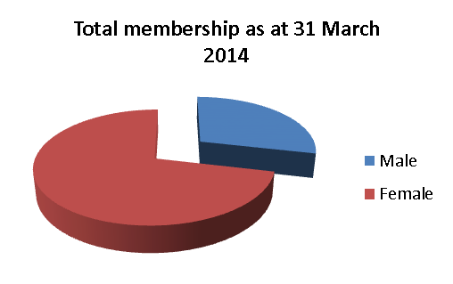

**Members aged from 16 to 102 years**

**Average pension in payment £5,047.60**

**Average spouses pension £2,772.69**

Membership of the Fund has increased by 5% over the year:

|  |  |  |  |  |
| --- | --- | --- | --- | --- |
| **At 31 March 2014** | **Active scheme members** | **Deferred pensioners** | **Pensions in payment** | **Total** |
| Scheduled bodies | 50,765 | 50,374 | 39,629 | 140,768 |
| Admitted bodies | 3,979 | 3,521 | 2,649 | 10,149 |
| **Total** | **54,744** | **53,895** | **42,278** | **150,917** |
| **At 31 March 2013** |  |  |  |  |
| Scheduled bodies | 49,369 | 46,596 | 38,386 | 134,351 |
| Admitted bodies | 3,594 | 3,241 | 2,499 | 9,334 |
| **Total** | **52,963** | **49,837** | **40,885** | **143,685** |

The Pension Fund Committee is required to receive regular reports from the Treasurer to the Fund on the administration of the Fund ensuring that best practice standards are satisfied and met and to satisfy itself and justify to all stakeholders, including fund employers that the Fund is being run on an efficient and effective basis. A Service Level Agreement (SLA) exists between the Pension Fund and the service provider. The SLA contains specific service level standards and corresponding service level targets and an [Annual Administration Report](http://www.yourpensionservice.org.uk/local_government/index.asp?siteid=5921&pageid=33736&e=e) is presented to the Pension Fund Committee.

**Performance**

Pension administration services are provided to Lancashire County Pension Fund by Your Pension Service (YPS). The service performance continues to exceed SLA targets and consistently exceeds its key performance indication;

***'to calculate and pay all retirement benefits within 10 working days'***

Overall achievement against SLA targets over the year was 98%. The service has experienced an unprecedented increase in workload since November 2013 and the launch of LCC's Budget Challenge. More than 1,300 voluntary redundancy estimates were processed between November 2013 and March 2014.

Over the year the service produced over 100,000 online benefit statements for active and deferred Scheme members. Annual newsletters were posted online alongside the statements. E-mail alerts were also sent to Scheme members who had signed up to "My Pension Online" to promote the roadshows and raise awareness of the 2014 scheme changes.

**Customer Service**

During the year, the Services dedicated Partnerships Team undertook a variety of events, courses and presentations. In addition the team visited a number of employers to maintain and improve working relationships.

The communication and promotion of the new LGPS2014 was a key priority during the year and as well as hosting roadshows, the team also hosted employer training events with payroll and HR practitioners from employers across Lancashire in attendance.

The service's annual employer conference was held in November. The event showcased new ways of working with employers and the monthly submission of data via the new employer portal; EPIC.

The annual Director's Brief for Chief Finance Officers was held in December. The Fund Actuary attended to report the initial results of the 2013 triennial valuation and the briefing was followed up with one to one surgeries for employers to discuss the financial impact of the results upon their organisation.

A dedicated pension's helpdesk is the first point of contact for members and employers. Over the year 90% of calls were successfully answered, meeting the SLA target.

**Legislative Changes**

During the year significant legislative change encompassed the introduction of the new Local Government Pension Scheme with effect from 1 April 2014.

The Public Service Pensions Act received royal assent on 25April 2013 setting out the new legal framework for public service pension schemes, including the LGPS. The Act reflects the recommendations made by the Independent Public Service Pension Commission chaired by Lord Hutton.

After completing a statutory consultation in August 2013, legislation outlining the LGPS rules from 1 April 2014 was made to provide:

* a pension scheme design based on career average pay
* an accrual rate of 1/49th of pensionable pay
* revaluation of benefits in line with CPI
* a Normal Pension Age equal to State Pension Age
* an average contribution rate of 6.5%
* a new low cost 50/50 option where half the contribution rate can be paid in return for half the benefits
* a vesting period of 2 year

Later in the year legislation was passed to remove access to the Scheme for new councillors from 1 April 2014. Existing councillor members as at 31 March 2014 will leave the scheme at the end of their current fixed term of office.

**Auto enrolment**

Following the changes to the law on workplace pensions, all employers are now legally required to automatically enrol certain staff into a pension scheme and make contributions. Employers have varying staging dates up to the final staging date of April 2017.

In order to support member organisations, the Your Pension Service website was updated to include a dedicated page in the employer's area, with guides and links to useful information regarding auto enrolment.

Employers were encouraged to ask questions and seek guidance from the service and auto enrolment was included as an agenda item for the annual employer visits.

Lancashire County Council were the first employer within the Fund to stage auto enrolment.

The following targets were set to measure the success of the Lancashire County Council campaign:

* To increase the number of LCC employees in the LCPF by 5%
* To achieve an opt out rate of less than 50%

The campaign resulted in an increase in LCC membership due to auto enrolment of 7% and an indicated opt out rate of 37%, thus exceeding both targets. This work is being replicated with other employers on request.

**Service developments**

Employer Services is an online tool, launched in December 2013, to allow employers to access their own employee's records. It enables them to check personal and financial data, and run benefit estimates without the need to contact Your Pension Service.

Your Pension Service has worked closely with BT Lancashire Services to develop a solution to meet the additional demands of the LGPS2014.

A new Employer Information Collection system ("EPIC") has been developed to take data securely from employers, with the aim of meeting the requirement for more regular data collection more easily and cost effectively.

**Charges**

Your Pension Service makes a charge to the Pension Fund on a per member basis which is restricted to the lower quartile as reported in national benchmarking returns. This charge is currently set at £21.50 per member against a benchmark of £23.00.

**Other information**

For further information relating to the administration of the Scheme please refer to the [Communication Policy Statement](http://www.yourpensionservice.org.uk/web/viewdoc.asp?id=64645) and the [Pensions Administration Strategy Statement](http://www.yourpensionservice.org.uk/web/viewdoc.asp?id=72142).

Your Pension Service can be contacted at:

PO Box 100

County Hall

Preston

PR1 0LD

Telephone: 01772 530530

E-mail: AskPensions@lancashire.gov.uk

# <http://www.yourpensionservice.org.uk>

1. **Knowledge & Skills Framework**

**CIPFA Pensions Finance Knowledge and Skills Framework**

The Chartered Institute of Public Finance and Accountancy (CIPFA) published its code of practice on public sector pensions finance knowledge and skills in October 2011. The Code has been devised in response to Lord Hutton's recommendation that every public sector pension scheme (and individual LGPS fund) should have a properly constituted, trained and competent "Pensions Board". It also represents a key element in complying with the relevant principles of investment practice laid out in Local Government Pension Scheme (Management and Investment of funds) regulations 2009 regarding Effective Decision making.

The Code is intended to be used in conjunction with the CIPFA Pension Finance Knowledge and Skills Frameworks (KSF) which enhances where necessary, levels of knowledge and skill held by all those, whether members or officers, involved in the management and oversight of public sector pension funds.

The Code became effective from 1 April 2012 and is mandatory for CIPFA members as part of their standards of professional practice, and was adopted by the Pension Fund Committee at its meeting on 3 February 2012 in order to ensure good governance and training practices, and to support the Treasurer who, as a CIPFA member, has a professional requirement to comply with the Code.

In order to ensure best practice within the Fund, and to comply with the Public Service Pensions Act 2013, a Training Plan for those charged with governance and financial management of the Lancashire County Pension Fund (Committee Members and Officers) should be developed on an annual basis. At its meeting of 7 June 2013, the Pension Fund Committee agreed to the development of such a training programme.

Central to this is the tenet that the Fund should secure appropriate training, having assessed the professional competence of both those involved in pension scheme financial management and those with a policy, management or oversight role.

It is not required that each individual demonstrates a level of expertise in every aspect of scheme governance and management, but rather that as a group both the Fund's Officers and the Committee has a level of knowledge and skills to ensure effective decision making.

Committee Members and Officers are also required to undertake training to satisfy the obligations placed upon them by the:

* Myners Principles (as detailed in the Statement of Investment Principles);
* Pensions Regulations and the Pensions Regulator;
* CIPFA Code of Practice on Public Sector Pensions Finance Knowledge and Skills; and the LGPS Governance Compliance Statement.

**Approach**

The Fund's approach to training is supportive in nature with the intention of providing committee members and officers with regular sessions that contribute to their level of skills and knowledge. Primarily based upon pre-committee training sessions, it also involves updates from officers and independent advisers. Details of external events are also circulated as appropriate. This is in addition to an expectation that committee members will undertake some self-directed learning outside of the formal training. Fund officers are also available to provide additional support and advice.

The key elements of the plan are designed to support members of the Committee in gaining the necessary knowledge and skills as a collective group over the following areas required by the CIPFA Knowledge and Skills Framework:

##### Pension Fund governance;

* Accounting and Audit standards;
* Procurement of financial services;
* Investment performance and risk management;
* Financial markets and product knowledge;
* Actuarial methods and valuation.

##### It is comprised of a combination of internally developed training sessions, updates from officers and independent advisers, external events, and self-directed learning.

Planning and monitoring that both committee members and the officers of the scheme comply with these requirements is provided through the adoption of an annual training plan, which was agreed by the Pension Fund Committee on 29 November 2013, and can be accessed at [Lancashire County Pension Fund Training Plan](http://mgintranet/documents/s31688/Appendix%20A.pdf)

In addition, the Council currently subscribes to a web-based knowledge and skills self-assessment tool, developed by Hymans Robertson in conjunction with the CIPFA Pensions Network, to enable officers and elected members to help identify any gaps in their knowledge or skills. Use of the on-line toolkit was set aside during 2013/14 in favour of other forms of support as set out in the agreed Training Plan.

Details of training provided and attended during 2013/14 are given below:

|  |  |  |  |  |
| --- | --- | --- | --- | --- |
| Date | Subject | Training provider | Venue | Number of attendees |
| 07/06/13 | Introduction to the Pension Fund | Internal – Treasurer to the Pension Fund, and other members of the Team | County Hall, Preston | 18 |
| 06/09/13 | Property investment and Private Equity Strategy | Internal – Chief investment Officer | County Hall, Preston | 15 |
| 29/11/13 | The role of the Fund's Actuary and the 2013 Valuation | John Livesey - Mercers | County Hall, Preston | 14 |
| 15/01/14 | Pension Fund Basics 1 | Internal – Head of Public Market Investment | County Hall, Preston | 13 |
| 12/02/14 | Pension Fund Basics 2 | Internal – Head of Public Market Investment | County Hall, Preston | 14 |
| 20/03/14 | Environmental, Social and Governance Investment Strategy | Seminar | Merseyside Pension Fund | 2 |

1. **Investment Policy and Performance**

**Structure**

There are four levels of responsibility for the investment management of the Lancashire County Pension Fund.

1. The County Council’s Pension Fund Committee takes major policy decisions and monitors overall performance. The Pension Fund Committee comprises fourteen County Councillors and seven voting co-optees representing other interested organisations;
2. The Investment Panel recommends specific investment allocations in line with the Committee's policy decisions, approves individual investments and monitors the activity of the Fund’s external managers. The Investment Panel consists of two independent external investment advisers, the Chief Investment Officer, the Deputy County Treasurer and the Treasurer to the Pension Fund, who acts as Chair;
3. The investment management team of Fund employees undertake day-to-day investment fund selection, monitoring and due-diligence;
4. Finally, external investment managers (or managers of unitised investments held by the Fund) fix precise weightings and select the individual investments within their particular remit.

A more detailed description of the responsibilities of the Committee, its Sub-Committees and the Panel is found in the Governance Policy Statement. [Governance Policy Statement](http://www.yourpensionservice.org.uk/local_government/index.asp?siteid=5921&pageid=33736&e=e)

In line with the investment strategy adopted by the Pension Fund Committee in 2010 and more detailed sub-strategies adopted since then, the Fund's investments are divided into four principal sub groups as follows:

**Equities:** The Fund holds both public and private equity investments. The public equity investments are managed by five active managers who operate differing and complementary styles of investment selection and two unitised investment funds. The remit of six of these seven pools is unconstrained, high conviction investment in Global equities. The final manager has a remit to invest in emerging market equities. Private equity investments are held through a variety of closed-ended limited partnerships, invested over a wide range of inception dates and managed by a diverse collection of different managers all under the oversight of Capital Dynamics.

**Property:** The Fund invests in a significant portfolio of directly owned UK commercial properties which are managed by Knight Frank. In addition, the Fund has a small allocation to a unitised European real estate investment fund managed by M&G.

**Infrastructure:** The Fund has allocations to a number of different global infrastructure funds, and also invests directly in renewable energy infrastructure projects throughout the world through its majority-owned infrastructure partnership, Red Rose Infrastructure LLP.

**Credit strategies:** The Fund has an internally managed portfolio of different types of credit investment, split into four broad categories – emerging markets sovereign debt, non-investment grade secured lending, cyclical credit opportunities and long-dated debt secured on real assets. These investments include both direct loans made by the Fund and a variety of different externally managed funds.

In addition, whilst the Fund continues to reallocate its investments in line with the revised investment strategy, amounts earmarked for future investments are held in transition accounts, cash, liquid bond funds and directly held investment grade bonds.

A summary of portfolio values by investment manager, as at 31 March 2014, is shown below.

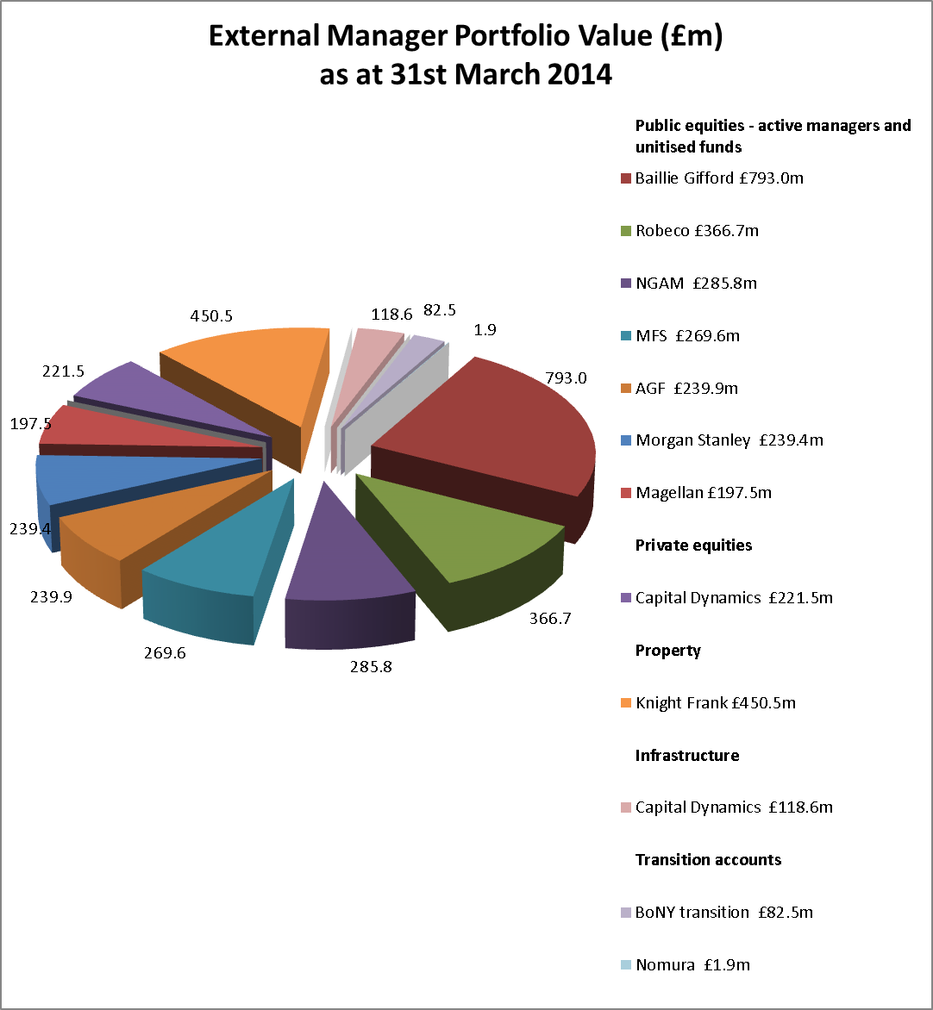

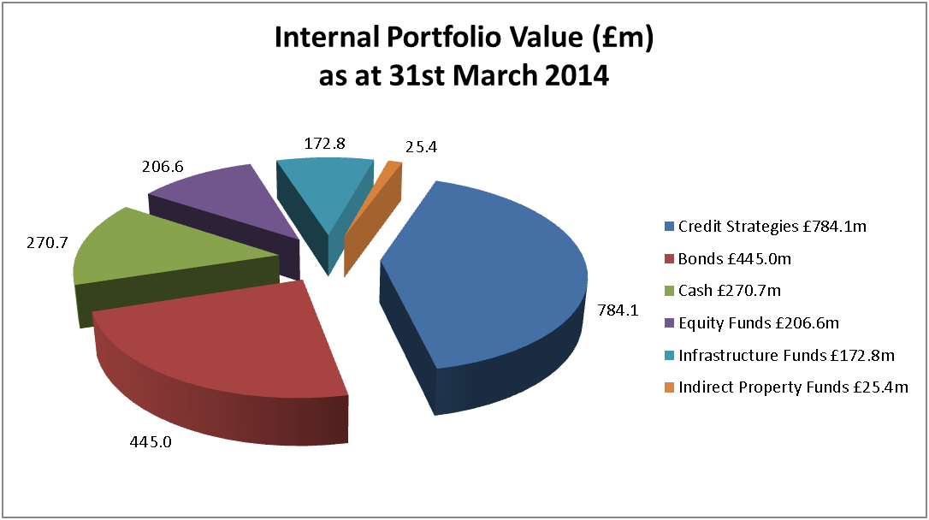

During 2013/14 the implementation of the revised investment strategy continued.

The Fund reduced its exposure to equity markets, finally exiting from residual passive equity mandates whilst adding two actively managed equity investments through seed investments in newly listed UCITS funds launched by AGF (emerging markets) and Magellan (global equities).

The identification of and allocation to investments to the transition of credit and fixed income assets was also completed. Whilst commitments have been made, some of these investment allocations are expected to take a further twelve months to be fully deployed. The Fund also identified a series of liquid investment funds into which assets earmarked for future investments can be held with the expectation of low volatility but whilst seeking to reduce investment performance drag associated with the transition.

**Performance**

The value of the Fund's assets has grown by 87% over the last ten years as shown in the following chart. Fund growth arises from investment returns and contributions made to the scheme by employers and employees, reduced by benefits paid out.

The Fund is invested to meet its own liabilities over the medium to long-term and therefore its performance should be judged not in absolute terms, but rather against those objectives and over a corresponding period. Annual returns can be volatile, as seen in 2008/09 (fund down 20%) and 2009/10 (fund up 35%) and do not necessarily indicate the underlying health of the Fund.

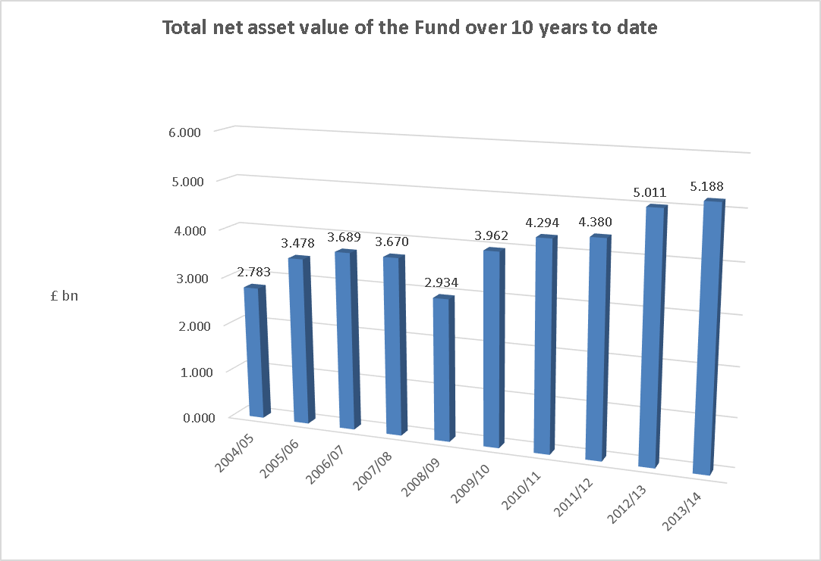

The performance of the Fund is measured against a Fund specific benchmark with individual managers being given performance targets which are linked to market returns for the assets they manage. Details of these can be found in the [Statement of Investment Principles](http://www.yourpensionservice.org.uk/web/viewdoc.asp?id=64641). The performance of investment managers is reviewed on a regular basis by the investment management team and Investment Panel and any recommendations arising from those reviews are considered by the Committee.

The Fund subscribes to the annual WM Survey of UK Local Authority Pension Funds, which shows comparisons with other local authority pension funds. However, absolute performance versus other local authority funds, which will certainly have different investment strategies designed to meet their own liability profile, may be misleading. The Fund's primary objective, to have assets available to meet pension liabilities as they fall due, requires the fund to consistently match or outperform the actuarial assumption of investment returns, being UK Gilts +2.5%.

The chart below shows the total return of the Fund compared to the fund specific benchmark and the actuarial fund return assumption of Gilts +2.5% measured over 1, 3, 5 and 10 years to 31 March 2014:

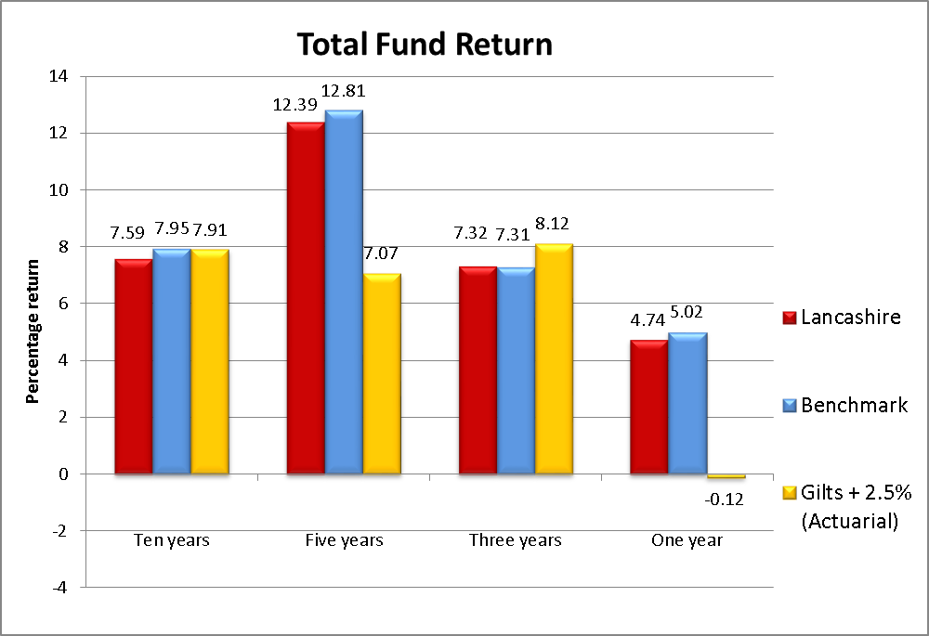

In the year to 31 March 2014, The Total Fund return amounted to 4.7% against a benchmark of 5.0%. This significantly outperformed the Gilts+2.5% actuarial return assumption of -0.1%% for the same period. The five year performance of the fund also shows a comfortable excess return over the actuarial assumption.

The results for the year to 31 March 2014 were adversely affected by a number of factors.

Firstly, the switch to a global investment strategy has increased the fund's exposure to non-sterling currencies, notably the US Dollar, Euro and various emerging market currencies. During the course of the year, sterling strengthened significantly against these currencies (for example from a rate against the US Dollar of $1.5229 at 1 April 2013 to a rate of $1.6662 on 31 March 2014, causing a depreciation in the sterling valuation of dollar denominated assets of 8.6%). The fund's strategy is to seek out investments with the most favourable characteristics for the fund in the long run, wherever these may be situated globally. Currency fluctuations will have an increased impact on short-term investment performance, therefore, but over the long-term this impact should diminish, to be outweighed by the superior investment characteristics of the new strategy.

Secondly, as mentioned earlier, the transition to the new investment strategy was further accelerated in the past twelve months. This part of the transition has involved switching investments between different investment types and markets and therefore incurring one-off transaction costs including bid/offer spreads. Furthermore, the transition has required the fund to hold increased levels of cash and other liquid assets which typically deliver a lower investment return than the long-term investments that the fund is targeting. Finally, whilst commitments have been made to new investment strategies, these are not yet fully funded, meaning that the enhanced investment returns that are expected in the long term are not yet reflected in annual performance. It is anticipated that the drag on performance caused by these factors will continue to a lesser extent into the next financial year, but that the year ended 31 March 2014 will be the year that has been most impacted.

Finally, the long term nature of Private Equity and Infrastructure allocations are such that, investment during the initial stages (years 1-3) creates performance drag but is expected to generate higher returns in the later stages (years 4-7). In a steady-state, with equal proportions of investments at different stages of their life, this effect may balance itself out. However, as the fund is currently in the process of increasing allocations to both Private Equity and Infrastructure, the investment drag of early years is likely to be disproportionately affecting short term investment returns.

Despite these adverse factors, underlying investment performance continues to be strong, with initial local currency investment returns in line with expectations for new investments made during the year. Performance figures where an investment has been in place for less than a year would not be meaningful, but will be reported in future years in line with the broad categories outlined above.

**Public equity investments**

The performance of active equity managers which have been in place for over a year is shown in the chart that follows.

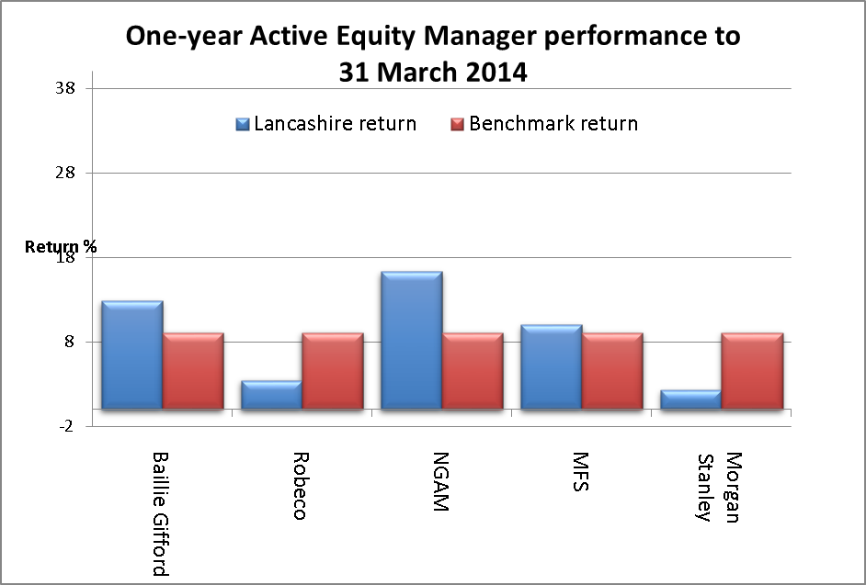

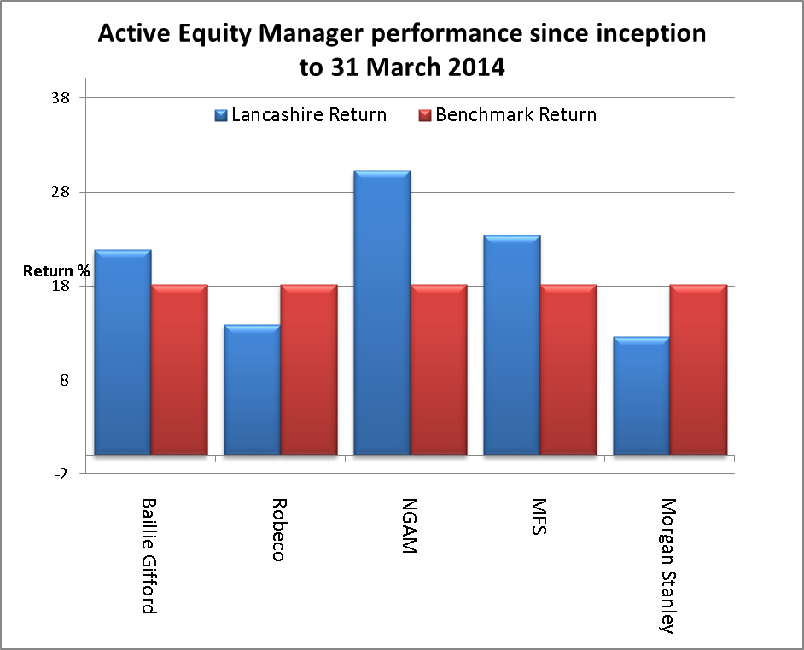

Active managers have discretion to make investments that deviate from the benchmark allocation, within agreed constraints and tolerances. These decisions will reflect their views on market conditions within various countries or between different types of instrument.

As part of an overall equity portfolio strategy Robeco and Morgan Stanley were installed as defensive managers. As expected in a strongly performing market they have underperformed their benchmark. Baillie Gifford, NGAM and MFS were appointed with a growth bias and their out-performance against the benchmark reflects this. It is pleasing that these investments are performing as expected.

The largest ten equity holdings of the Fund at 31 March 2014 were:

|  |  |  |
| --- | --- | --- |
| **Equity** | **Market value at 31 March 2014** | **Percentage of net assets of the Fund** |
|  | **£m** | **%** |
| Prudential GBP 0.05 | 24.0 | 0.46 |
| British American Tobacco ORD GBP 0.25 | 23.3 | 0.45 |
| Nestle SA CHF 0.10 (Regd) | 22.5 | 0.43 |
| Royal Caribbean Cruises COM STK | 21.8 | 0.42 |
| Naspers 'N' ZAR 0.02 | 21.6 | 0.42 |
| Unilever Plc ORD GBO 0.031111 | 19.1 | 0.37 |
| Roche Holdings AG GENUSSCHEINE NPV | 17.4 | 0.34 |
| Reckitt Benck GRP ORD GBP0.10 | 16.4 | 0.32 |
| Google INC CLA | 15.9 | 0.31 |
| Ryanair Holdings ORD EURO 0.00635 | 15.6 | 0.30 |
|  | **197.6** | **3.82** |

**Private equity and real assets**

Other investment types that have been in place for more than one year are property, infrastructure and private equity. The annual and since inception performance of these investments is shown in the graphs below.

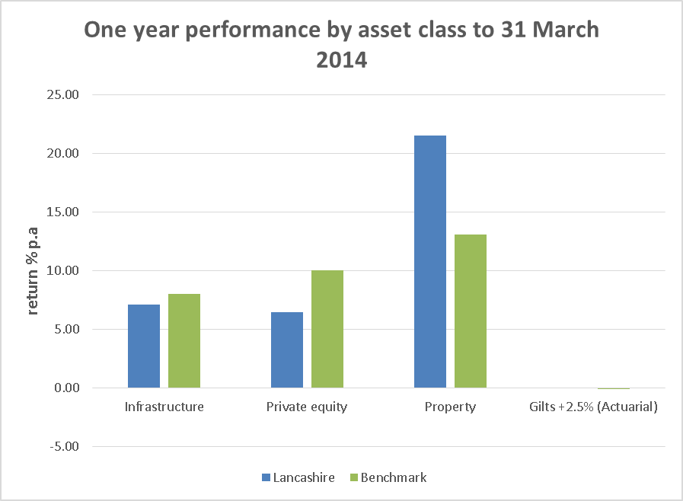

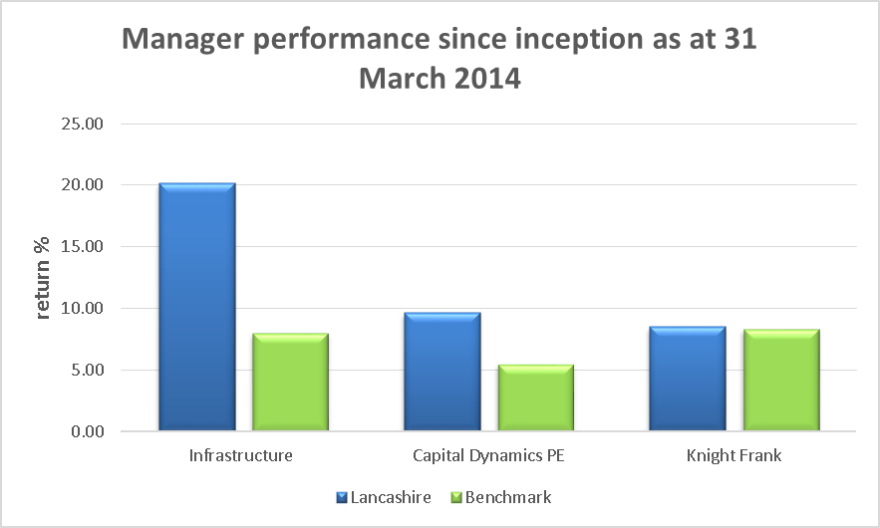

Annual valuations of these less liquid asset types can be affected by a number of factors and as with all of the Fund's investments, it is long term performance and the role that an investment plays in meeting the overall needs of the Fund that is key.

Whilst private equity and infrastructure investments appear to have performed below benchmark during this period, the long term performance since those investments were made is strongly positive.

Private equity investments provide alternative opportunities to generate returns linked to movements in stock markets, but because of the higher level of engagement by asset managers in the investee companies, gives an expectation of better long term returns. This return expectation has to be balanced with the higher risk profile and the lack of liquidity of these investments, which typically have to be held from 7-10 years before gains can be realised.

Infrastructure investments offer long-term returns that are expected to closely match the Fund's investment needs and in addition provide an important source of diversification. As well as investing in traditional infrastructure funds, the Fund has made a number of direct investments in global infrastructure, notably in the renewable energy sector. The ability to invest directly minimises fee costs and has enabled the Fund to negotiate favourable investment terms which have delivered excellent performance since inception.

Property has performed well against benchmark during this period, due to the specific characteristics of the portfolio; and in the long term is slightly ahead of the benchmark return. Property investments play an important role in the Fund, both because of the diversification benefits that they bring and also because of the generated rental income which can be used to fund member benefits without the need to liquidate other investments.

The largest ten direct property holdings of the Fund at 31 March 2014 were:

|  |  |  |  |
| --- | --- | --- | --- |
|  | **Property** | **Sector** | **Market value**  **£m** |
|  | Sainsburys Store, Chesham | Shops | 31.3 |
|  | Princes Mead Shopping Centre, Farnborough | Shopping Centre | 24.5 |
|  | St Edmundsbury Retail Park, Bury St Edmunds | Retail Warehouse | 19.6 |
|  | 1-3 Dufferin Street, London | Offices | 18.5 |
|  | Tuscany Way, Wakefield | Industrial / Warehouse | 17.5 |
|  | Benson House, Leeds | Offices | 17.2 |
|  | Tuttles Lane, Wymondham | Shops | 16.7 |
|  | Weir Road, Wimbledon | Industrial / Warehouse | 15.6 |
|  | Woodbridge Meadows, Guildford | Hotel / Commercial | 15.0 |
|  | Stukeley Road Retail Park, Huntingdon | Retail Warehouse | 14.7 |
|  |  |  | **190.5** |

**Credit Strategies**

The implementation of the credit strategy is ongoing and therefore a number of investments have not yet been held for a meaningful period. However, the initial investments in emerging markets sovereign debt and non-investment grade secured lending have been in place for over twelve months.

Emerging markets sovereign debt returns suffered from a number of different effects, notably the crisis in Ukraine and the strength of sterling as mentioned above. The investments that have been held for twelve months in this asset class recorded a loss of 13.7% during the year. This category of investment is considered likely to benefit from long-term global economic growth and strengthening of the currencies of emerging economies, even if there is some short term volatility in valuations. In addition, the asset class provides useful diversification from other more mainstream credit investments. The Fund added further investments to this credit category during the year.

Investments in non-investment grade secured debt that were in the portfolio for the full twelve month period were all denominated in US Dollars and recorded a return of 4.5% during the period. When translated into sterling, however, this corresponds to a loss of 4.7%. These investments deliver regular cash flows that are reinvested and the investment team believes that they provide an excellent risk/reward profile when compared to traded non-investment grade bonds. Once again, the fund added further investments to this credit category during the year.

Investments in cyclical credit opportunities were built up during the year. These investments seek to take advantage of specific opportunities where 'technical' factors mean that assets can be acquired at a discount to their long-term economic value. This might include assets that changes in regulation are forcing banks to sell at a discount; bonds that have been downgraded, forcing certain investors to sell; or asset types that are out of favour in the markets or where liquidity have significantly reduced, such as securitisations. Generating returns in this credit category requires manager skill in terms of identifying investment opportunities and in managing investments to achieve maximum value. The investments may be illiquid, having to be held to maturity in order to realise gains. They provide a diversification benefit and the expectation of excess returns over the medium term.

The final credit strategy to which commitments were made, although no funds are yet invested, is debt secured on real assets. These investments are typically long dated in nature and provide a very low risk profile, being secured, typically, on real estate. If properly underwritten and managed, there is a very low expectation of loss. Whilst generating lower expectations of return, these investments should provide a very good match for the long term needs of the fund to generate income and protect the value of the portfolio.

At the end of the period, Investments in emerging market debt amounted to £310.7m (6.0% of the Fund), £280.2m was invested in non-investment grade secured lending and £179.6m in cyclical credit opportunities. Target levels of investment are approximately £360m in each category.

**n/a**

**Asset allocations**

The Fund is continuing to implement its revised investment strategy agreed in 2010, in actively managing asset allocations toward the agreed proportions. The investment strategy focusses on reducing reliance on assets such as listed equities, in favour of asset classes such as infrastructure and floating rate credit, and to deliver increased diversification, for example through increased allocations to real estate and other alternative asset types.

This move towards a diverse range of asset classes has resulted in equity accounting for 50% of the Fund at 31 March 2014, compared with 77% four years ago. In the same period, infrastructure and credit investments have increased from 16% to 33%.

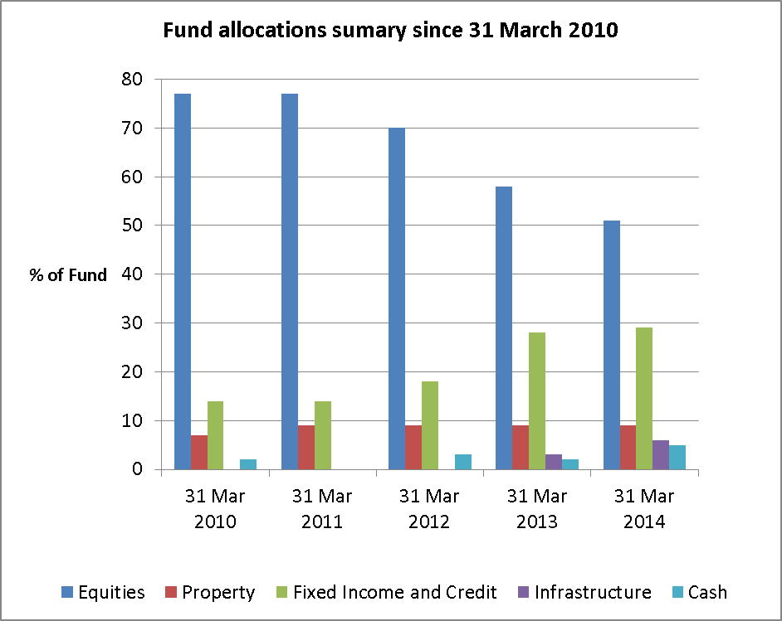

At 31 March 2014, equitiy holidngs were towards the middle of their target range (40%-60%), property remained just below the bottom of its target range (10%-20%), and credit and infrastructure were mid-range (20%-40%). The Fund was holding higher levels of cash than would be the strategic level, due to the impact of transitioning between different asset classes as explained above.

Detailed asset class allocations, and a comparison with the previous year is shown below:

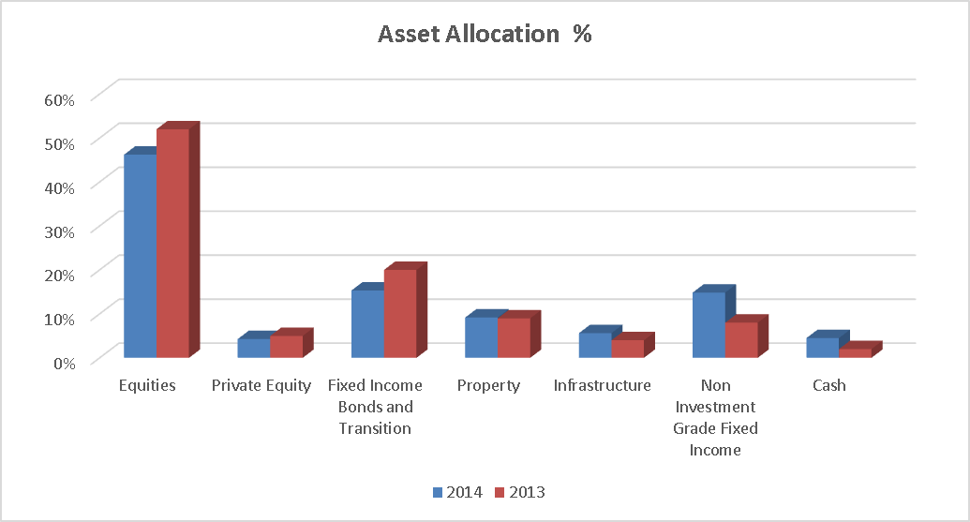

As at 31 March 2104, the fund had committed to invest a further £151.4m in infrastructure investments and £248.7m in various credit strategies, with these commitments expected to be drawn down over the following twelve month period.

**Policies in respect of Socially Responsible Investment and Voting**

**Social, Environmental and Ethical Considerations**

The Fund takes an active stance on corporate governance issues.  It uses Pensions Investment Research Consultants (“PIRC”) to vote on its behalf at shareholder meetings.  PIRC advises on Socially Responsible Investment issues and issues voting guidance and commentary for shareholder meetings.  PIRC is instructed to vote the Fund's shares in accordance with its guidelines unless an Investment Manager requests a different vote for investment management reasons.  In the latter case, the Treasurer to the Fund will decide how best to cast the vote in the long-term financial interest of the Fund.

The Fund is a member of the Local Authority Pension Fund Forum (“LAPFF”), which is a group of like-minded local authority pension funds that meet to discuss and act / engage in respect of Socially Responsible Investment and Corporate Governance issues.

**Policy on Voting**

For many years, the Fund has followed the voting recommendations of PIRC with the Fund's managers being instructed to vote at shareholder meetings in accordance with PIRC's recommendations. PIRC has been acting as the Fund's proxy since 2011 and casting the Fund's votes directly at shareholder meetings.

The Fund's investment managers receive advance notice of PIRC's voting intentions and may raise concerns with the Fund if they do not believe the recommended stance on a vote is in the best financial interests of the Fund.

The Committee delegates its agreement of any significant departure from the guidelines proposed by the managers, to the Treasurer as Chair of the Investment Panel. In all voting decisions the long-term financial interests of the Fund are paramount. There were no occurrences of this during 2013/14.

**Policy on Risk**

The consideration of investment risk forms part of the Pension Fund's overall risk register, which is presented to Pension Fund Committee on a bi-annual basis. The key risks and associated mitigations are replicated in the Funding Strategy Statement.

The overriding objective of the Fund in respect of its investments is to minimise risk and maximise return while reducing volatility.  The structure of the investment management arrangements has been implemented in order to produce a balanced spread of risk for the portfolio.

Operational risk is minimised by having custody of the Fund's financial assets provided by a regulated, external, third party, professional custodian.

The Fund’s Global Custodian is Northern Trust.  All public market investments are held in nominee accounts of Northern Trust.

All private market investments, including interests in private equity, property and other pooled funds are held directly in the name of Lancashire County Council as administering authority of the Lancashire County Pension Fund.  Northern Trust provides detailed investment accounting and reconciliation services for all private market investments.

The title deeds in respect of the Fund’s property holdings are held by Lancashire County Council and its property solicitors.

**Compliance with Myners Principles**

The Fund is compliant with the Myners Principles, details of which can be found in the Statement of Investment Principles. [Statement of Investment Principles](https://www.yourpensionservice.org.uk/local_government/index.asp?siteid=5921&pageid=33736&e=e)

1. **Accounts of the Fund**

**Responsibilities for the Statement of Accounts**

#### The Responsibilities of the Administering Authority

The Administering Authority is required:

* To make arrangements for the proper administration of the financial affairs of the Lancashire County Pension Fund (Pension Fund), and to ensure that an officer has the responsibility for the administration of those affairs. For Lancashire County Council, the respective officer is the County Treasurer, who is also the Treasurer to the Pension Fund;
* To manage its affairs to secure economic, efficient and effective use of resources, and to safeguard its assets.

#### The Responsibilities of the Treasurer to the Pension Fund

The Treasurer to the Pension Fund is responsible for the preparation of the Pension Fund’s statement of accounts. In accordance with the CIPFA Code of Practice on Local Authority Accounting in Great Britain (the Code), the statement is required to present fairly the financial position of the Pension Fund at the accounting date, and its income and expenditure for the year then ended.

In preparing this statement of accounts, the Treasurer to the Pension Fund has:

* Selected suitable accounting policies and then applied them consistently;
* Made judgements and estimates that were reasonable and prudent;
* Complied with the Code.

In addition, the Treasurer to the Pension Fund has:

* Kept proper accounting records which were up to date;
* Taken responsible steps for the prevention and detection of fraud and other irregularities.

The Statement of Accounts relate to the financial year ended 31 March 2014 and include the Fund Account and the Statement of Net Assets which are prepared in accordance with standard accounting practice as outlined in the notes to the accounts of the Pension Fund.

Gill Kilpatrick CPFA

Treasurer to the Lancashire County Pension Fund

27 June 2014

**INDEPENDENT AUDITOR’S STATEMENT TO THE MEMBERS OF LANCASHIRE COUNTY PENSION FUND ON THE PENSION FUND FINANCIAL STATEMENTS**

We have examined the pension fund financial statements for the year ended 31 March 2014, which comprise the Fund Account, the Net Assets Statement and the related notes.

This report is made solely to the members of Lancashire County Pension Fund in accordance with Part II of the Audit Commission Act 1998 and for no other purpose, as set out in paragraph 48 of the Statement of Responsibilities of Auditors and Audited Bodies published by the Audit Commission in March 2010. To the fullest extent permitted by law, we do not accept or assume responsibility to anyone other than the Authority and the Authority's Members as a body, for our audit work, for this report, or for the opinions we have formed.

**Respective responsibilities of the Treasurer to the Pension Fund and the auditor**

As explained more fully in the Statement of the Responsibilities of the Treasurer to the Pension Fund, the Treasurer of the Pension Fund is responsible for the preparation of the pension fund’s financial statements in accordance with applicable United Kingdom law.

Our responsibility is to report to you our opinion on the consistency of the pension fund financial statements within the pension fund annual report with the pension fund financial statements in the statement of accounts of Lancashire County Pension Fund, and its compliance with applicable law and the CIPFA/LASAAC Code of Practice on Local Authority Accounting in the United Kingdom 2013/14.

We also read the other information contained in the pension fund annual report and consider the implications for our report if we become aware of any apparent misstatements or material inconsistencies with the pension fund financial statements.

We conducted our work in accordance with Bulletin 2008/3 issued by the Auditing Practices Board. Our report on the administering authority’s full annual statement of accounts describes the basis of our opinion on those financial statements.

**Opinion**

In our opinion, the pension fund financial statements are consistent with the full annual statement of accounts of Lancashire County Pension Fund for the year ended 31 March 2014 and comply with applicable law and the CIPFA/LASAAC Code of Practice on Local Authority Accounting in the United Kingdom 2013/14.

We have not considered the effects of any events between the date we signed our report on the full annual statement of accounts and the date of this statement.

Karen Murray

Director for and behalf of Grant Thornton UK LLP

Appointed Auditor

4 Hardman Square

Spinningfields

Manchester

M3 3EB

29 September 2014

**Fund Account**

|  |  |  |  |  |
| --- | --- | --- | --- | --- |
|  | **Note** | **2013/14**  **£m** |  | **2012/13**  **£m** |
| **Dealing with members, employers and others directly involved in the fund** |  |  |  |  |
| Contributions | 5 | 214.0 |  | 202.7 |
| Transfers in | 6 | 7.1 |  | 9.9 |
|  |  | 221.1 |  | 212.6 |
| Benefits | 7 | (221.1) |  | (210.2) |
| Payments to and on account of leavers  Administrative expenses | 8  9 | (15.3)  (4.5) |  | (12.6)  (5.0) |
|  |  | (240.9) |  | (227.8) |
| **Net withdrawals from dealings with members** |  | **(19.8)** |  | **(15.2)** |

|  |  |  |  |  |
| --- | --- | --- | --- | --- |
| **Return on investments** |  |  |  |  |
| Investment income | 10 | 105.3 |  | 120.8 |
| Profit and loss on disposal of investments and change in market value of investments | 13 | 102.9 |  | 532.6 |
| Investment management expenses | 19 | (11.3) |  | (7.2) |
| **Net return on investments** |  | **196.9** |  | **646.2** |
| **Net increase (decrease) in the net assets available for benefits during the year** |  | **177.1** |  | **631.0** |

##### Net Asset Statement

|  |  |  |  |  |
| --- | --- | --- | --- | --- |
|  | **Note** | **31/03/14**  **£m** |  | **31/03/13**  **£m** |
| Investment assets | 13 | 5,192.8 |  | 4,990.9 |
| Investment liabilities | 13 | (21.3) |  | (1.9) |
| Current assets | 20 | 28.3 |  | 31.7 |
| Current liabilities | 21 | (11.7) |  | (9.7) |
| Net assets of the fund available to fund benefits at the period end |  | 5,188.1 |  | 5,011.0 |

The Pension Fund's financial statements do not take account of liabilities to pay pensions and other benefits after the period end.

### This statement of accounts is that upon which the auditor should enter his certificate and opinion. It presents fairly the position of the Lancashire County Pension Fund at 31 March 2014 and its income and expenditure for the year then ended.

|  |  |
| --- | --- |
| **Gill Kilpatrick CPFA** | **County Councillor Clare Pritchard** |
|  |  |
| **Treasurer to the Lancashire**  **County Pension Fund** | **Chair of the Audit and Governance Committee** |
|  |  |

### Notes to the Financial Statements

1. **Pension Fund Operations and Membership**

The Lancashire County Pension Fund is part of the Local Government Pension Scheme and is administered by Lancashire County Council. The county council is the reporting entity for this pension fund.

The published accounts show that in 2013/14 cash inflows during the year consisted of £326.4 million and cash outflows were £252.2 million, representing a net cash inflow of £74.2 million (compared with an inflow of £98.4 million in the previous year). Benefits payable amounted to £221.1 million and were partially offset by net investment income of £105.3 million (including £12.4 million accrued dividends); contributions of £214.0 million and transfers in of £7.1 million produced the positive cash inflow.

1. **General**

The Fund is governed by the Superannuation Act 1972. The fund is administered in accordance with the following secondary legislation:

* the LGPS (Benefits, Membership and Contributions) Regulations 2007 (as amended)
* the LGPS (Administration) Regulations 2008 (as amended)
* the LGPS (Management and Investment of Funds) Regulations 2009

The fund is a contributory defined benefit pension scheme administered by Lancashire County Council to provide pensions and other benefits for pensionable employees of Lancashire County Council, the district councils in Lancashire and a range of other scheduled and admitted bodies within the county area. Teachers, police officers and fire-fighters are not included within the Fund as they come within other national pension schemes.

The investments of the Pension Fund are managed by eleven external investment managers. The asset allocation and policy in respect of the investments of the Fund is determined by the Pension Fund Committee, which meets four times a year with the Investment Panel in attendance. The Investment Panel meet at least quarterly, or otherwise as necessary. The panel are responsible for making recommendations to the Pension Fund Committee in relation to the investment strategy of the fund as well as monitoring the activities and performance of the investment managers. Full details of the Panel and Committees responsibilities are published in the Funds Statement of Investment Principles and are available from the Funds website at [Your Pension Service - Lancashire Fund Information](http://www.yourpensionservice.org.uk/local_government/index.asp?siteid=5921&pageid=33736&e=e)

1. **Membership**

Membership of the LGPS is voluntary and employees are free to choose whether to join the scheme, remain in the scheme or make their own personal arrangements outside the scheme.

The 297 organisations participating in the Lancashire County Pension Fund include:

* Scheduled bodies, which are local authorities and similar bodies whose staff are automatically entitled to be members of the fund.
* Admitted bodies, which are other organisations that participate in the fund under an admission agreement between the fund and the relevant organisation.
* Admitted bodies include voluntary, charitable and similar bodies or private contractors undertaking a local authority function following outsourcing to the private sector.

# Participation in the Pension Fund

|  |  |  |
| --- | --- | --- |
|  | **Number at**  **31 March 2014** | **Number at**  **31 March 2013** |
| 1. Active Scheme Members   Scheduled Bodies | 50,536  4,208 | 49,391  3,572 |
| Admitted Bodies |
| **Total** | **54,744** | **52,963** |
| 1. Pensioners   Pensions in Payment | 42,278  53,895 | 40,885  49,837 |
| Preserved Pensions |
| **Total** | **96,173** | **90,722** |
|  |  |  |
| **Total membership** | **150,917** | **143,685** |

1. **Funding**

Benefits are funded by contributions and investment earnings. Contributions are made by active members of the fund in accordance with the LGPS (Benefits, Membership and Contributions) Regulations 2007 and range from 5.5% to 7.5% of pensionable pay for the financial year ending 31 March 2014. Employee contributions are matched by employers' contributions which are set based on triennial actuarial funding valuations. The last valuation relevant to the year ended 31st March 2014 was done at 31 March 2010. The latest valuation was carried out at 31st March 2013 and will be applicable for 3 financial years commencing 1st April 2014. Currently employer contributions range from 8.6% to 70.3% of pensionable pay.

1. **Benefits**

Pension benefits under the LGPS are based on final pensionable pay and length of pensionable service in the following summary:

|  |  |  |
| --- | --- | --- |
|  | **Service Pre 1 April 2008** | **Service post 31 March 2008** |
| **Pension** | Each year worked is worth 1/80 x final pensionable salary | Each year worked is worth 1/60 x final pensionable salary |
| **Lump sum** | Automatic lump sum of 3 x salary.  In addition, part of the annual pension can be exchanged for a one-off tax free cash payment. A lump sum of £12 is paid for each £1 of pension given up | No automatic lump sum.  Part of the annual pension can be exchanged for a one-off tax free cash payment. A lump sum of £12 is paid for each £1 of pension given up |

There are a range of other benefits provided under the scheme including early retirement, disability pensions and death benefits.

Benefits are index-linked in order to keep pace with inflation. In June 2010, the government announced that the method of indexation would change from the retail price index to the consumer price index. This change took effect from 1 April 2011.

**LGPS 2014**

During the year significant legislative change encompassed the introduction of the new Local Government Pension Scheme with effect from 1 April 2014.

The Public Service Pensions Act received royal assent on 25 April 2013 setting out the new legal framework for public service pension schemes, including the LGPS. The Act reflects the recommendations made by the Independent Public Service Pension Commission chaired by Lord Hutton.

After completing a statutory consultation in August 2013, legislation outlining the LGPS rules from 1 April 2014 was made to provide:

* a pension scheme design based on career average pay
* an accrual rate of 1/49th of pensionable pay
* revaluation of benefits in line with the CPI
* a Normal Pension Age equal to State Pension Age
* an average contribution rate of 6.5%
* a new low cost 50/50 option where half the contribution rate can be paid in return for half the benefits
* a vesting period of two years

Later in the year legislation was passed to remove access to the Scheme for new councillors from 1 April 2014. Existing councillor members as at 31 March 2014 will leave the Scheme at the end of their current fixed term of office.

1. **Basis of Preparation**

The Statement of Accounts summarises the fund's transactions for the 2013/14 financial year and its position at year-end as at 31 March 2014. The accounts have been prepared in accordance with the Code of Practice on Local Authority Accounting in United Kingdom 2013/14 which is based on International Financial Reporting Standards (IFRS), as amended for the UK public sector.

The accounts summarise the transactions of the fund and report the net assets available to pay pension benefits. They do not take account of obligations to pay pensions and benefits which fall due after the end of the financial year. The actuarial present value of promised retirement benefits, value on an International Accounting Standard (IAS) 19 basis, is disclosed in note 27 of these accounts.

1. **Accounting Policies**

**Fund Account revenue recognition**

* **Contribution income**

Normal contributions both from members and from the employer are accounted for on an accruals basis at the percentage rate recommended by the fund actuary in the payroll period to which they relate.

Employers' augmentation contributions and pension strain contributions are accounted forinthe period in which the liability arises. Any amount due in the year but unpaid will be classed as a current financial asset. Amounts not due until future years are classed as long term financial assets.

* **Transfers**

Transfer values represent amounts received and paid during the period for individual members who have either joined or left the fund during the financial year and are calculated in accordance with Local Governance Pension Scheme Regulations.

Individual transfers in/out are accounted for when received/paid, which is normally when the member liability is accepted or discharged.

Transfers in from members wishing to use the proceeds of their additional voluntary contributions to purchase scheme benefits are accounted for on a receipts basis and are included in transfers in. Bulk (group) transfers are accounted for on an accruals basis in accordance with the terms of the transfer agreement.

* **Investment Income**

1. Interest income

Interest income is recognised in the fund account as it accrues, using the effective interest rate of the financial instrument as at the date of acquisition or origination. Income includes the amortisation of any discount or premium, transaction costs or other differences between the initial carrying amount of the instrument and its amount at maturity calculated on an effective interest rate basis.

1. Dividend income

Dividend income is recognised on the date the shares are quoted ex-dividend. Any amount not received by the end of the reporting period is disclosed in the net asset statement as a current financial asset.

1. Distribution from pooled funds

Distributions from pooled funds are recognised at the date of issue. Any amount not received by the end of the reporting period is disclosed in the net asset statement as a current financial asset.

1. Rental income

Net rental income from operating leases on properties owned by the fund is recognised on a straight line basis over the term of the lease. Any lease incentives granted are recognised as an integral part of the total rental income, over the term of the lease. Contingent rents are only recognised when contractually due.

1. Movement in the net market value of investments

Changes in the net market value of investments (including investment properties) are recognised as income and comprise all realised and unrealised profits/losses during the year.

**Fund Account –expense items**

* **Benefits payable**

Pensions and lump sum benefits payable include all amounts known to be due as at the end of the financial year. Any amounts due but unpaid are disclosed on the net asset statement as current liabilities.

* **Taxation**

The fund is a registered public service scheme under section 1(1) of Schedule 36 of the Finance Act 2004 and as such is exempt from UK income tax on interest received and from capital gains tax on the proceeds of investments sold. Income from overseas investments suffers withholding tax in the country of origin, unless exemption is permitted. Irrecoverable tax is accounted for as a fund expense as it arises.

* **Administrative** **expenses**

All administrative expenses are accounted for on an accruals basis. All other costs of administration are borne by the employer. The administration and processing expenses are a proportion of relevant officers' salaries in respect of the time allocated to pension administration and investment issues.

* **Investment Manager expenses**

Investmentmanagement expenses are accounted for on an accruals basis. They include the fees paid and due to the fund managers, custodian, actuarial fees and performance measurement and investment consultant fees.

Fees of the external investment managers and custodian are agreed in the respective mandates governing their appointments. Broadly, these are based on the market value of investments under their management and therefore increase or reduce as the value of these investments change.

In addition the fund has negotiated with the following managers that an element of their fee be performance related:

* MFS
* Morgan Stanley

Performance related fees paid in 13/14 were £1.5m. No fees were paid in 12/13 as these managers were only appointed in October 2012.

Where an investment manager's fee note has not been received by the net asset statement date, an estimate based on market value of their mandate as at year end is used for the inclusion in the fund account. In 2013/14 £2.8m of fees is based on such estimates (2012/13 £2.2m).

The costs of the council's in-house fund management team are charged direct to the fund and a proportion of the council's costs representing management time spent by officers on investment management are also charged to the fund.

**Net asset statement**

* **Financial Instruments**

Financial assets, other than loans and receivables, are included in the net asset statement on a fair value basis as at the reporting date. A financial asset is recognised in the net asset statement on the date the fund becomes party to the contractual acquisition of the asset. From this date any gains or losses arising from changes in the fair value of the asset are recognised by the fund.

The assets and liabilities held by Lancashire County Pension Fund are classified as designated at fair value through profit and loss. Loans and receivables and liabilities are included at amortised cost.

**Loans and receivables**

Loans and receivables are non-derivative financial assets with fixed or determinable payments that are not quoted in an active market.

The fund's loans and receivables comprise of trade and other receivables and cash deposits.

**Financial liabilities at amortised cost**

Financial liabilities at amortised cost are the default category for financial instruments that do not meet the definition of financial liabilities at fair value through profit and loss.

* **Valuation of Investments**

Investments are shown at their fair value as at 31 March 2014. The fair value is the current bid price for quoted securities and unitised securities.

Transaction costs are included in carrying value of investments. Transaction costs include costs charged directly to the Pension Fund, such as fees, commissions paid to agents, brokers and dealers, levies by regulatory agencies and securities exchanges and transfer taxes and duties.

Investments in private equity are valued at fair value in accordance with the guidelines issued by the British Venture Capital Association, or equivalent.

The methodologies adopted in valuing financial instruments are explained in greater detail in note 16.

* **Currency Translation**

Assets and liabilities denominated in foreign currency are stated in the accounts by the application of the appropriate closing rate of exchange ruling at 31 March 2014. Any gains or losses are treated as part of a change in market value of investments.

* **Acquisition costs of Investments**

The Acquisition costs of investments are included within the purchase price.

* **Property**

The fund's freehold and leasehold properties were valued on 31 March 2014 by Cushman & Wakefield, acting as External Valuer. The valuations were in accordance with the requirements of the RICS Valuation standards and the International Valuation Standards. The valuation of each property was on the basis of Market Value, assuming that the property would be sold subject to any existing leases. The valuer's opinion of Market Value and Existing Use Value was primarily derived using comparable recent market transactions on arm's length terms.

* **Derivatives**

The fund uses derivative financial instruments to manage its exposure to specific risks arising from its investment activities. The fund does not hold derivatives for speculative purposes.

Derivative contract assets are fair valued at bid prices and liabilities are fair valued at offer prices. Changes in fair value of derivative contracts are included in change in market value.

Future contracts are exchange traded and fair value is determined using exchange prices at their reporting date. Amounts due or owed to the broker are amounts outstanding in respect of initial margin and variation margin.

Forward foreign exchange contracts, are over the counter contracts and are valued by determining the gain or loss that arise from closing out the contract at the reporting date, by entering into an equal and opposite contract at that date.

* **Cash and cash equivalents**

Cash comprises of cash in hand and on demand deposits.

Cash equivalents are short-term, highly liquid investments that are readily convertible to known amounts of cash and that are subject to minimal risk of changes in value.

* **Financial liabilities**

The fund recognises financial liabilities at fair value other than loans and receivables at the reporting date. A financial liability is recognised in the net asset statement on the date the fund becomes party to a liability. From this date any gains or losses arising from changes in the fair value of the liability are recognised by the fund.

* **Actuarial present value of promised retirement benefits**

The actuarial present value of promised retirement benefits is assessed on a triennial basis by the scheme actuary in accordance with the requirements of IAS19 and relevant actuarial standards.

As permitted under IAS 26 the fund has opted to disclose the actuarial present value of promised retirement benefits by way of a note to the net asset statement (note 27).

* **Additional voluntary contributions**

The AVC providers to the Pension Fund are Equitable Life and Prudential. The AVC’s are invested separately from the Pension Fund’s main assets and used to acquire additional money purchase benefits. These are not included in the Pension Fund accounts in accordance with section 4(2) (b) of the Local Government Pension Scheme (Management and Investment of Funds) Regulations 2009 (SI 2009/3093). Members participating in these AVC arrangements each receive an annual statement confirming the amounts held in their account and the movements during the year. A summary of the information provided by Equitable Life and Prudential is shown in note 18.

* **Securities Lending**

Investments lent under securities lending arrangements continue to be recognised in the net asset statement to reflect the scheme's continuing economic interest in the securities and are measured in accordance with the accounting policy for assets 'at fair value through profit and loss' or 'available for sale' as appropriate.

Collateral is marked to market, and adjusted daily. As the Fund has an obligation to return the collateral to the borrowers, collateral is excluded from the Fund valuation.

* **Contingent liabilities and contingent assets**

A contingent liability is a possible obligation that arises from past events whose existence will be confirmed by the occurrence or non-occurrence of one or more uncertain future events beyond the control of the Fund or a present obligation that is not recognised because it is not probable that an outflow of resources will be required to settle the obligation. A contingent liability also arises in extremely rare cases where there is a liability that cannot be recognised because it cannot be measured reliably. The Fund does not recognise a contingent liability but discloses its existence in the financial statements.

A contingent asset is a possible asset that arises from past events whose existence will be confirmed by the occurrence or non-occurrence of one or more uncertain future events beyond the control of the Fund. The Fund does not recognise contingent assets but discloses its existence where inflows of economic benefits are probable, but not virtually certain.

1. **Assumptions made about the future and other major sources of estimated uncertainty**

The Statement of Accounts contains estimated figures that are based on assumptions made by the Pension Fund about the future or that are otherwise uncertain. Estimates are made taking into account historical experience, current trends and other relevant factors.

However, because balances cannot be determined with certainty, actual results could be materially different from the assumptions and estimates.

The items in the Pension Fund's net asset statement at 31 March 2014 for which there is a significant risk of material adjustment in the forthcoming year are as follows:

|  |  |  |
| --- | --- | --- |
| Item | Uncertainties | Impact if actual results differ from assumptions |
| Private equity and infrastructure investments. | Private equity and infrastructure investments are valued at fair value in accordance with British Private Equity and Venture Capital Association guidelines / International Private Equity and Venture Capital Valuation guidelines or equivalent. | The market value of private equity and infrastructure investments in the financial statements totals £512.9m.  There is a risk that these investments might be under or overstated in the accounts. |
| Local authority bond valuations. | Local authority bonds are based on valuation techniques that require management judgements based on various factors. | The market value of local authority bonds totals £17.4m in the financial statements and there is a risk that this may be under or overstated. |
| Indirect overseas property valuations. | Overseas indirect properties are valued at the current open market value as defined by the RICS Appraisal and Valuation Standards. These investments are not publicly listed and as such there is a degree of estimation involved in the valuation. | Overseas indirect property investments in the financial statements total £25.4m.  There is a risk that these investments may be under or overstated in the accounts. |
| Pensions Liability | |  | | --- | | Estimation of the net liability to pay pensions depends on a number of complex judgements relating to the discount rate used, the rate at which salaries are projected to increase, changes in retirement ages, mortality rates and expected returns on pension fund assets. A firm of consulting actuaries (Mercers) is engaged to provide the authority with expert advice about the assumptions to be applied. | | The effects on the net pension liability of changes in individual assumptions can be measured. For instance, a 0.25% reduction in the discount rate assumption would increase the value of the liabilities by approximately £300 million. A 0.5% increase in assumed earnings inflation would increase the value of the liabilities by approximately £128m and a 1 year increase in assumed life expectancy would increase the liabilities by approximately £139m. |

1. **Contributions receivable**

|  |  |  |  |
| --- | --- | --- | --- |
|  | **2013/14**  **£m** |  | **2012/13**  **£m** |
| **Employers' contributions** |  |  |  |
| County Council | 67.5 |  | 61.3 |
| Scheduled Bodies | 74.0 |  | 71.2 |
| Admitted Bodies | 13.1 |  | 12.6 |
|  | 154.6 |  | 145.1 |
|  |  |  |
|  |  |  |
|  | **2013/14**  **£m** |  | **2012/13**  **£m** |
| **Pension Strain** |  |  |  |
| County Council | 1.6 |  | 2.1 |
| Scheduled Bodies | 3.6 |  | 3.5 |
| Admitted Bodies | 0.2 |  | 0.3 |
|  | 5.4 |  | 5.9 |
|  | 160.0 |  | 151.0 |
| **Employee contributions** |  |  |  |
| County Council | 22.2 |  | 20.6 |
| Scheduled Bodies | 26.8 |  | 26.3 |
| Admitted Bodies | 5.0 |  | 4.8 |
|  | 54.0 |  | 51.7 |
| Total contributions | 214.0 |  | 202.7 |

Within the employee contributions figure for 2013/14, £0.4m is voluntary and additional regular contributions. All employer contributions are normal contributions.

1. **Transfers in**

|  |  |  |  |
| --- | --- | --- | --- |
|  | **2013/14**  **£m** |  | **2012/13**  **£m** |
| Individual transfers in from other schemes | 7.1 |  | 9.9 |
|  | 7.1 |  | 9.9 |

1. **Benefits**

|  |  |  |  |  |
| --- | --- | --- | --- | --- |
|  | | **2013/14**  **£m** |  | **2012/13**  **£m** |
| Pensions | | 183.9 |  | 176.5 |
| Lump sum retirement benefits | | 33.2 |  | 28.3 |
| Lump Sum death benefits | | 4.0 |  | 5.4 |
|  | | 221.1 |  | 210.2 |
| **Relating to:** | |  |  |  |
| County Council | | 93.4 |  | 91.4 |
| Scheduled Bodies | | 112.9 |  | 105.7 |
| Admitted Bodies | | 14.8 |  | 13.1 |
|  | | 221.1 |  | 210.2 |
|  |  | |  | | |

1. **Payments to and on account of leavers**

|  |  |  |  |
| --- | --- | --- | --- |
|  | **2013/14**  **£m** |  | **2012/13**  **£m** |
| Individual transfers to other schemes | 12.9  2.4 |  | 12.6  0 |
| Bulk transfers to other schemes |  |
|  | 15.3 |  | 12.6 |

1. **Administrative expenses**

|  |  |  |  |
| --- | --- | --- | --- |
|  | **2013/14**  **£m** |  | **2012/13**  **£m** |
| Administration and processing | 4.2 |  | 3.8 |
| Audit fee* | 0.1 |  | 0.1 |
| Legal and other professional fees | 0.2 |  | 1.1 |
|  | 4.5 |  | 5.0 |

*The total amount payable for external audit services carried out by the appointed auditor in 2013/14 was £38k (£41k in 2012/13).

1. **Investment income**

|  |  |  |  |
| --- | --- | --- | --- |
|  | **2013/14**  **£m** |  | **2012/13**  **£m** |
| Fixed interest securities | 31.5 |  | 21.5 |
| Equity dividends | 36.8 |  | 59.5 |
| Index linked securities | 1.6 |  | 1.2 |
| Pooled investment vehicles | 6.4 |  | 6.3 |
| Net rents from properties | 23.5 |  | 25.0 |
| Interest on cash deposits | 3.2 |  | 2.8 |
| Other | 2.3 |  | 4.5 |
|  | 105.3 |  | 120.8 |
|  |  |  |  |

1. **Net rents from Properties**

|  |  |  |  |
| --- | --- | --- | --- |
|  | **2013/14**  **£m** |  | **2012/13**  **£m** |
| Rental Income | 27.4 |  | 28.1 |
| Direct operating expenses | (3.9) |  | (3.1) |
| Net income | 23.5 |  | 25.0 |
|  |  |  |  |

1. **Stock Lending**

Northern Trust the Fund's custodian, are authorised to release stock to a third party under stock lending arrangements up to the statutory limits for this activity. Stock lending income generated in 2013/14 was £1.2m (2012/13 £0.6m)

Securities on loan at the 31st March 2014 were £131.7m and are included in the net asset statement to reflect the scheme's continuing economic interest in the securities. This consisted of £129.9m of equities and £1.8m of bonds.

Collateral is marked to market, and adjusted daily. Additional collateral of between 2% and 5% is requested as an additional measure of industry standard practice to mitigate risk. As the Fund has an obligation to return the collateral to the borrowers, collateral is excluded from the Fund valuation. The collateral is non cash and totalled £139.8m of government bonds.

1. **Reconciliation of movements in investments and derivatives**

|  |  |  |  |  |  |  |  |  |  |  |  |  |  |  |  |  |
| --- | --- | --- | --- | --- | --- | --- | --- | --- | --- | --- | --- | --- | --- | --- | --- | --- |
|  | | **Market Value at 1 April 2013** | | **Purchases at cost and derivative payments** | | | | | **Sales proceeds and derivative receipts** | **Change in market**  **value** | | | **Market value at 31 March**  **2014** | | | |
|  | |  | **£m** |  | | **£m** | | | **£m** | **£m** | | | **£m** | | | |
| Fixed interest securities | |  | 843.6 |  | | 190.2 | (765.9) | | |  | | (34.9) |  | | 233.0 | |
| Equities | |  | 1,749.3 |  | | 972.5 | (954.8) | | |  | | 154.1 | 1,921.1 | | | |
| Index linked securities | |  | 164.9 |  | | 92.9 | (248.5) | | |  | | (9.3) |  | | 0.0 | |
| Pooled investments | |  | 1,601.2 |  | | 1,248.5 | (559.9) | | |  | | (50.9) | 2,238.9 | | | |
| Property | |  | 434.9 |  | | 15.0 | (43.3) | | |  | | 43.9 |  | | 450.5 | |
|  | |  | 4,793.9 |  | | 2,519.1 | (2,572.4) | | |  | | 102.9 | 4,843.5 | | | |
| Derivative contracts: |  | | | |  | | |  | | |  | | |  | |
| Forward currency contracts asset value | 121.4 | | | |  | | |  | | |  | | | 21.4 | |
| Cash deposits | 170.5 | | | |  | | |  | | |  | | | 315.5 | |
| Investment accruals | 21.6 | | | |  | | |  | | |  | | | 12.4 | |
| Investment assets | 5,107.4 | | | |  | | |  | | |  | | | 5,192.8 | |
|  |  | | | |  | | |  | | |  | | |  | |
| Forward currency contracts liability value | (118.4) | | | |  | | |  | | |  | | | (21.3) | |
| Portfolio value | 4,989.0 | | | |  | | |  | | |  | | | 5,171.5 | |

|  |  |  |  |  |  |  |  |  |  |  |  |  |  |  |  |  |  |  |  |  |  |  |  |  |  |  |  |
| --- | --- | --- | --- | --- | --- | --- | --- | --- | --- | --- | --- | --- | --- | --- | --- | --- | --- | --- | --- | --- | --- | --- | --- | --- | --- | --- | --- |
|  | | **Market Value at 1 April 2012** | | | | | | **Purchases at cost and derivative payments** | | | | | | | **Sales proceeds and derivative receipts** | | | **Change in market**  **value** | | | **Market value at 31 March**  **2013** | | | | | | |
|  | |  | | | **£m** | | |  | **£m** | | | | | | **£m** | | | **£m** | | | **£m** | | | | | | |
| Fixed interest securities | |  | | 623.4 | | | |  | 501.1 | | (471.9) | | | | | | |  | | 191.0 |  | | | | | 843.6 | |
| Equities | |  | | 1,613.7 | | | |  | 1,409.8 | | (1,581.2) | | | | | | |  | | 307.0 | 1,749.3 | | | | | | |
| Index linked securities | |  | | 124.6 | | | |  | 16.1 | | (29.1) | | | | | | |  | | 53.3 |  | | | | | 164.9 | |
| Pooled investments | |  | | 1,466.3 | | | |  | 696.6 | | (558.9) | | | | | | |  | | (2.8) | 1,601.2 | | | | | | |
| Property | |  | | 383.9 | | | |  | 72.1 | | (5.3) | | | | | | |  | | (15.8) |  | | | | | 434.9 | |
|  | | 4,211.9 | | | |  | 2,695.7 | | (2,646.4) | | | | | | |  | | 532.7 | 4,793.9 | | | | | | |
| Derivative contracts: |  | | | | |  | | | | | |  | | | |  | | | | | |  | | | | | | |
| Futures | | | | 0.2 | | | 0.4 | | | | | | | (0.5) | | | | | (0.1) | | | | | | 0.0 | |
| Forward currency  contracts * | | | | 1.6 | | |  | | | | | | |  | | | | |  | | | | | 3.0 | | |
| Cash deposits | | | | 126.8 | | |  | | | | | | |  | | | | |  | | | | | 170.5 | | |
| Investment accruals | | | | 19.4 | | |  | | | | | | |  | | | | |  | | | | | 21.6 | | |
| Portfolio value | | | | 4,359.9 | | |  | | |  | | | | | | | | |  | | | | | 4,989.0 | | |
|  | | |  | | | |  | | | | | |  | | | |  | | | | | |  | | | |

*Forward currency contracts have been disaggregated into asset and liability contracts for reporting as at 31st March 2014, the net asset position having been reported previously.

Within the £102.9m increase in market value of investments during the 2013/14 financial year, a reduction in market value of £33.9m relates to assets for which fair value is not based on observable market data. The valuation policy for these assets is outlined in note 16.

Transaction costs are included in the cost of purchases and in sale proceeds. Transaction costs include costs charged directly to the Pension Fund, such as fees, commissions paid to agents, brokers and dealers, levies by regulatory agencies and securities exchanges and transfer taxes and duties. Transaction costs incurred during the year 2013/14 amounted to £1.4m (2012/13: £2.2m).

The investment assets at 31 March 2014 were managed by eleven external investment managers, with the remaining managed in-house. The following table shows the split of the investment assets by investment manager.

|  |  |  |  |  |  |  |  |
| --- | --- | --- | --- | --- | --- | --- | --- |
| **Summary of Manager's Portfolio Values** | | | |  |  |  | |
|  |  |  |  |  |  |  | |
|  |  | **31/03/14** | |  | **31/03/13** | | |
|  |  | **£m** | **%** |  | **£m** | | **%** |
| Externally Managed |  |  |  |  |  | |  |
| Equities |  |  |  |  |  | |  |
| Baillie Gifford |  | 793.0 | 15% |  | 703.1 | | 14% |
| Robeco |  | 366.7 | 7% |  | 354.5 | | 7% |
| NGAM |  | 285.8 | 6% |  | 245.7 | | 5% |
| MFS |  | 269.6 | 5% |  | 245.0 | | 5% |
| AGF |  | 239.9 | 5% |  | 0.0 | | 0% |
| Morgan Stanley |  | 239.4 | 5% |  | 234.1 | | 5% |
| Magellan |  | 197.5 | 4% |  | 0.0 | | 0% |
| Nomura Transition |  | 1.9 | 0% |  | 1.7 | | 0% |
|  |  |  |  |  |  | |  |
| Private equity |  |  |  |  |  | |  |
| Capital Dynamics |  | 221.5 | 4% |  | 229.1 | | 4% |
|  |  |  |  |  |  | |  |
| Infrastructure |  |  |  |  |  | |  |
| Capital Dynamics |  | 118.6 | 2% |  | 77.5 | | 1% |
|  |  |  |  |  |  | |  |
| Credit and fixed income transition |  |  |  |  |  | |  |
| BNYM Transition |  | 82.5 | 2% |  | 929.4 | | 19% |
|  |  |  |  |  |  | |  |
| Property |  |  |  |  |  | |  |
| Knight Frank |  | 450.5 | 9% |  | 434.9 | | 9% |
|  |  |  |  |  |  | |  |
| Index tracking – multi asset |  |  |  |  |  | |  |
| Legal & General |  | 0.0 | 0% |  | 582.1 | | 12% |
|  |  |  |  |  |  | |  |
| **Externally Managed Portfolios** |  | **3,266.9** | **64%** |  | **4,037.1** | | **81%** |
| Internally Managed |  |  |  |  |  | |  |
|  |  |  |  |  |  | |  |
| Credit Strategies |  | 784.1 | 15% |  | 424.0 | | 9% |
| Bonds and cash |  | 715.7 | 14% |  | 224.4 | | 5% |
| Equity Funds |  | 206.6 | 4% |  | 0.0 | | 0% |
| Infrastructure Funds |  | 172.8 | 3% |  | 76.9 | | 1% |
| Indirect Property Funds |  | 25.4 | 0% |  | 7.5 | | 0% |
| Emerging Markets ETF |  | 0.0 | 0% |  | 219.1 | | 4% |
| **Internally Managed Portfolios** |  | **1,904.6** | **36%** |  | **951.9** | | **19%** |
|  |  |  |  |  |  | |  |
| **Total Portfolio Values** |  | **5,171.5** | **100%** |  | **4,989.0** | | **100%** |
|  |  |  |  |  |  | |  |

|  |  |  |  |
| --- | --- | --- | --- |
|  | **31/03/14**  **£m** |  | **31/03/13**  **£m** |
|  |  |  |  |
| **Fixed Interest Securities** |  |  |  |
| UK public sector quoted | 0.0 |  | 294.9 |
| UK corporate bonds quoted | 76.0 |  | 225.0 |
| Overseas corporate bonds quoted | 157.0 |  | 323.7 |
|  | 233.0 |  | 843.6 |

|  |  |  |  |
| --- | --- | --- | --- |
|  | **31/03/14**  **£m** |  | **31/03/13**  **£m** |
| **Equities** |  |  |  |
| UK quoted | 231.3 |  | 218.3 |
| Overseas quoted | 1,689.8 |  | 1,531.0 |
|  | 1,921.1 |  | 1,749.3 |
|  |  |  |  |
|  | **31/03/14**  **£m** |  | **31/03/13**  **£m** |
| **Index Linked Securities** |  |  |  |
| UK quoted | 0.0 |  | 164.9 |
|  | 0.0 |  | 164.9 |

|  |  |  |  |
| --- | --- | --- | --- |
|  | **31/03/14** |  | **\*31/03/13** |
|  | **£m** |  | **£m** |
| **Pooled Investment Vehicles** |  |  |  |
| **UK Managed Funds:**  Equity funds | 0.0 |  | 166.0 |
| Fixed Income funds | 47.0 |  | 0 |
| Venture Capital | 264.8 |  | *218.8 |
| **Overseas Managed Funds:** |  |  |  |
| Equity Funds | 644.1 |  | 632.2 |
| Fixed Income funds | 970.3 |  | *412.0 |
| Property funds | 25.1 |  | 7.5 |
| Venture Capital | 287.6 |  | 164.7 |
|  | 2,238.9 |  | 1,601.2 |
|  |  |  |  |

* Change in disclosure category has led to a prior year restatement of asset classes.

|  |  |  |  |
| --- | --- | --- | --- |
|  | **31/03/14**  **£m** |  | **31/03/13**  **£m** |
| **Properties** |  |  |  |
| UK – Freehold | 389.8 |  | 346.4 |
| UK – Long Leasehold | 60.7 |  | 88.5 |
|  | 450.5 |  | 434.9 |

|  |  |  |  |
| --- | --- | --- | --- |
|  | **31/03/14**  **£m** |  | **31/03/13**  **£m** |
| Balance at start of the year | 434.9 |  | 383.9 |
| Additions | 15.0 |  | 72.1 |
| Disposals | (43.3) |  | (5.3) |
| Net gain/loss on fair value | 43.9 |  | (15.8) |
| Balance at the end of the year | 450.5 |  | 434.9 |

**Derivative contracts (forward currency positions**)

|  |  |  |  |  |  |  |
| --- | --- | --- | --- | --- | --- | --- |
| one to six months | USD | 3.7 | AUD | -4.2 | 2.2 | -2.3 |
| one to six months | USD | 30.5 | CHF | -26.6 | 18.3 | -18.1 |
| up to one month | GBP | 0.1 | USD | -0.1 | 0.1 | -0.1 |
| up to one month | JPY | 17.0 | GBP | -0.1 | 0.1 | -0.1 |
| up to one moth | USD | 0.4 | EUR | -0.3 | 0.3 | -0.3 |
| up to one month | USD | 0.7 | JPY | -70.1 | 0.4 | -0.4 |
|  | | | | |  |  |
| Open forward currency contracts at 31 March 2014 | | | | | 21.4 | -21.3 |
| Net forward currency contracts at 31 March 2014 | | | | |  | 0.1 |
|  | | | | |  |  |
| Prior year comparative | | | | |  |  |
| Open forward currency contracts at 31 March 2013 | | | | | 121.3 | -118.4 |
| Net forward currency contracts at 31 March 2013 | | | | |  | 2.9 |

Forward Foreign currency contracts are used to hedge against foreign currency movements.

|  |  |  |  |
| --- | --- | --- | --- |
|  | **31/03/14**  **£m** |  | **31/03/13**  **£m** |
| **Cash Deposits** |  |  |  |
| Sterling | 148.0 |  | 116.6 |
| Foreign currency | 167.5 |  | 53.9 |
|  | 315.5 |  | 170.5 |

1. **Financial Instruments classification**

Accounting policy describes how different asset classes of financial instruments are measured, and how income and expenses, including fair value gains and losses are recognised. The following table analyses the carrying amounts of financial assets and liabilities by category and net asset statement heading.

|  |  |  |  |  |  |  |
| --- | --- | --- | --- | --- | --- | --- |
| **31/03/14** | **Designated at fair value through profit or loss** | | **Loans and receivables** | | **Financial liabilities at amortised cost** | |
|  | **£m** | | **£m** | | **£m** | |
| **Financial assets** |  |  |  |  |  |  |
| Fixed interest securities |  | 233.0 |  | - |  | - |
| Equities |  | 1,921.1 |  | - |  | - |
| Pooled investment vehicles |  | 1,661.4 |  | - |  | - |
| Pooled property investments |  | 25.1 |  |  |  |  |
| Venture Capital |  | 552.4 |  |  |  |  |
| Derivative Contracts |  | 21.4 |  |  |  |  |
| Cash deposits |  | - |  | 315.5 |  | - |
| Investment accruals |  | 12.4 |  | - |  | - |
| Debtors |  | - |  | 28.3 |  | - |
| **Total Financial Assets** |  | **4,426.8** |  | **343.8** |  | **-** |
|  |  |  |  |  |  |  |
| **Financial liabilities** |  |  |  |  |  |  |
| Derivative contracts |  | 21.3 |  | - |  | - |
| Creditors |  | - |  | - |  | 11.7 |
| **Total Financial Liabilities** | | **21.3** |  | **-** |  | **11.7** |  |

|  |  |  |  |  |  |  |
| --- | --- | --- | --- | --- | --- | --- |
| **31/03/13** | **Designated at fair value through profit or loss** | | **Loans and receivables** | | **Financial liabilities at amortised cost** | |
|  | **£m** | | **£m** | | **£m** | |
| **Financial assets** |  |  |  | - |  | - |
| Fixed interest securities |  | 843.6 |  | - |  | - |
| Equities |  | 1,749.3 |  | - |  | - |
| Index linked securities |  | 164.9 |  | - |  | - |
| Pooled investment vehicles |  | 1,601.2 |  | - |  | - |
| Derivative contracts |  | 4.9 |  | - |  | - |
| Cash deposits |  | - |  | 170.5 |  | - |
| Investment accruals |  | 21.6 |  | - |  | - |
| Debtors |  | - |  | 31.7 |  | - |
| **Total Financial Assets** |  | **4,385.5** |  | **202.2** |  | **-** |
| **Financial liabilities** |  |  |  |  |  |  |
| Derivative contracts |  | 1.9 |  | - |  | - |
| Creditors |  | - |  | - |  | 9.7 |
| **Total Financial Liabilities** |  | **1.9** |  | **-** |  | **9.7** |
|  |  |  |  |  |  |  |

1. **Net gains and losses on financial instruments**

The net gain on financial assets at fair value through profit and loss is £59.0m

(2012/13 £548.4m)

1. **Financial Instruments – Valuation**

**Valuation of financial instruments carried at fair value**

The valuation of financial instruments has been classified into three levels according to quality and reliability of information used to determine fair values.

**Level 1**

Level 1 fair value measurements are those derived from unadjusted quoted prices in active markets for identical assets or liabilities. Examples include quoted equity investments, unit trusts, UK pooled fixed income funds, overseas pooled fixed income funds, UK and overseas quoted fixed interest securities.

Listed investments are shown at bid prices. The bid value of the investment is based on the bid market quotation of the relevant stock exchange.

**Level 2**

Level 2 investments are those where quoted market prices are not available, for example where an instrument is traded in a market that is not considered to be active or valuation

techniques are used to determine fair value and where these techniques use inputs that are based significantly on observable market data. The technique for valuing these assets is independently verified.

**Level 3**

Level 3 portfolios are those where at least one input which could have a significant effect on the instrument's valuation is not based on observable market data. Such instruments include internally managed overseas equity funds, overseas quoted fixed income investments, pooled UK fixed income investments, private equity, infrastructure, local authority bonds and indirect overseas property investments, which are valued using various valuation techniques that require significant management judgement in determining appropriate assumptions, including earnings, public market comparables and estimated future cash flows.

The values of the investment in private equity and infrastructure are based on valuations provided to the private equity and infrastructure funds in which Lancashire County Pension Fund has invested. These valuations are prepared in accordance with the International Private Equity and Venture Capital Valuation Guidelines or equivalent, which follow the valuation principles of IFRS and US GAAP. Valuations are performed annually mainly, and at the end of December. Cash flow adjustments are used to roll forward the valuations to 31 March as appropriate.

The overseas indirect property fund is valued monthly by external valuers, CB Richard Ellis (CBRE). CBRE are one of the largest firms of valuers in Europe, and are required to ensure that the assets in the Fund are valued each month at the current open market value, as defined by the RICS Appraisal and Valuation Standards. The valuation methodology is also subject to independent review by E&Y.

The local authority bond value is based on a valuation technique that requires management judgement including earnings multiples, public market comparables and estimated future cash flows.

The table below provides an analysis of the financial assets and liabilities of the Pension Fund grouped into level 1 to 3 based on the level of which the fair value is observable.

|  |  |  |  |  |  |  |  |  |  |
| --- | --- | --- | --- | --- | --- | --- | --- | --- | --- |
| **31/03/14** | | **Level 1** | **Level 2** | | **Level 3** | | **Total** | | |
|  | | **£m** | **£m** | | **£m** | | **£m** | | |
| **Financial assets** | |  |  | |  | |  | | |
| Financial assets at fair value through profit and loss | | 3,314.6 | 179.9 | | 929.9 | | 4,424.4 | | |
| **Total Financial assets** | | **3,314.6** | **179.9** | | **929.9** | | **4,424.4** | | |
|  | |  |  | |  | |  | | |
| **Financial Liabilities** | |  |  | |  | |  | | |
| Financial liabilities at fair value through profit and loss | | 21.3 | - | | - | | 21.3 | | |
| **Total Financial Liabilities** | | **21.3** | **-** | | **-** | | **21.3** | | |
| **31/03/13** | | **\*Level 1** | **\*Level 2** | | **\*Level 3** | | **Total** | | |
|  | | **£m** | **£m** | | **£m** | | **£m** | | |
| **Financial assets** | |  |  | |  | |  | | |
| Financial assets at fair value through profit and loss | | *2,881.5 | *977.1 | | *648.3 | | 4,506.9 | | |
| **Total Financial assets** | | **2,881.5** | **977.1** | | **648.3** | | **4,506.9** | | |
| **Financial Liabilities** | |  |  | |  | |  | | |
| Financial liabilities at fair value through profit and loss | *118.4 | | - | | - | | 118.4 | | |
| **Total Financial Liabilities** | | **118.4** | | **-** | | **-** | | **118.4** | | |
| * Financial instruments at 31st March 2014 have been categorised at individual investment level rather than by asset class as was the policy at 31st March 2013. Comparatives have been restated accordingly. | | | | | | | | |
|  | | | | | | | | |  | | |  |  |  |

1. **Nature and extent of risks arising from Financial Instruments**

**Risk and risk management**

The Fund's primary long-term risk is that the Fund's assets will fall short of its liabilities (i.e. promised benefits payable to members). The aim of investment risk management is to balance the minimisation of the risk of an overall reduction in the value of the Fund with maximising the opportunity for gains across the whole Fund portfolio. The Fund achieves this through asset diversification to reduce exposure to market risk (price risk, currency risk and interest rate risk) and keep credit risk to an acceptable level. In addition, the Fund manages its liquidity risk to ensure there is sufficient liquidity to meet the Fund's forecast cash flow.

Responsibility for the Fund's risk management strategy rests with the Pension Fund Committee. Risk management policies are established to identify and analyse the risks faced by the Fund's operations. Policies are reviewed regularly to reflect change in activity and in market conditions.

**Market risk**

Market risk is risk of loss from fluctuations in equity and commodity prices, interest and foreign exchange rates and credit spreads. The Fund is exposed to market risk from its investment activities, particularly through its equity holdings.

The objective of the Fund's risk management strategy is to identify, manage and keep market risk exposure within acceptable parameters, whilst optimising the return on risk.

In general, excessive volatility in market risk is managed through the diversification of the portfolio in terms of geographical and industry sectors and individual securities. To mitigate market risk, the Fund and its investment advisors undertake appropriate monitoring of market conditions and benchmarking analysis.

**Other price risk**

Other price risk represents the risk that the value of a financial instrument will fluctuate as a result of changes in market prices (other than those arising from interest rate risk or foreign exchange risk), whether those changes are caused by factors specific to the individual instrument or its issuer or factors affecting all such instruments in the market.

The Fund is exposed to share and derivatives price risk. This arises from investments held by the Fund for which the future price is uncertain. All securities investments present a risk of loss of capital. Except for shares sold short, the maximum risk resulting from financial instruments is determined by the fair value of the financial instruments. Possible losses from shares sold short is unlimited.

The Fund's investment managers mitigate this price risk through diversification. The selection of securities and other financial instruments is monitored by the Fund to ensure it is within limits specified in the fund investment strategy.

**Other price risk – sensitivity analysis**

Following analysis of historical data and expected investment return movement during the financial year, in consultation with the Fund's investment advisors, the Fund has determined that the following movements in market price risks are reasonably possible for the 2013/14 reporting period.

|  |  |
| --- | --- |
| **Asset Type** | **Potential market movements (+/­-)** |
| UK Bonds | 4.8% |
| Overseas bonds | 4.8% |
| UK equities | 11.9% |
| Overseas equities | 11.9% |
| Index linked Gilts | 4.8% |
| Cash | 0% |
| Alternatives | 3.8% |
| Property | 2.7% |

The potential price changes disclosed above are broadly consistent with a one-standard deviation movement in value of the asset. The sensitivities are consistent with the assumption contained in the investment advisors' most recent review. This analysis assumes that all other variables, in particular foreign currency exchange rates and interest rates, remain the same. Had the market of the Fund's investments increased/decreased in line with the above, the change in the net assets available to pay benefits in the market place would have been as follows (the prior year comparator is shown below):

|  |  |  |  |  |
| --- | --- | --- | --- | --- |
| **Asset Type** | **31/03/14** | **Percentage Change** | **Value on Increase** | **Value on**  **Decrease** |
|  | **£m** | **%** | **£m** | **£m** |
| Cash and Cash equivalents | 328.0 | 0.0% | 328.0 | 328.0 |
| **Investment portfolio assets:** |  |  |  |  |
| UK bonds | 76.0 | 4.8% | 79.6 | 72.3 |
| Overseas bonds | 157.0 | 4.8% | 164.5 | 149.5 |
| Total equities | 1,921.1 | 11.9% | 2,149.7 | 1,692.5 |
| Alternatives | 2,238.9 | 3.8% | 2,324.0 | 2,153.8 |
| Property | 450.5 | 2.7% | 462.7 | 438.3 |
| **Total asset available to pay benefits** | **5,171.5** |  | **5,508.5** | **4,834.4** |

|  |  |  |  |  |
| --- | --- | --- | --- | --- |
|  |  |  |  |  |
| **Asset Type** | **31/03/13** | **Percentage Change** | **Value on Increase** | **Value on**  **Decrease** |
|  | **£m** | **%** | **£m** | **£m** |
| Cash and Cash equivalents | 195.1 | 0.0% | 195.1 | 195.1 |
| **Investment portfolio assets:** |  |  |  |  |
| UK bonds | 519.9 | 4.6% | 543.8 | 496.0 |
| Overseas bonds | 323.7 | 8.7% | 351.8 | 295.5 |
| Total equities | 1,749.3 | 12.8% | 1,973.2 | 1,525.5 |
| Index linked gilts | 164.9 | 8.1% | 178.2 | 151.5 |
| Alternatives | 1,601.2 | 3.6% | 1,658.8 | 1,543.6 |
| Property | 434.9 | 1.8% | 442.7 | 427.1 |
| **Total asset available to pay benefits** | **4,989.0** |  | **5,343.6** | **4,634.3** |

**Interest Rate Risk**

The Fund invests in financial assets for the primary purpose of obtaining a return on investments. These investments are subject to interest rate risks, which represent the risks that the fair value of future cash flow of a financial instrument will fluctuate because of changes in market interest rates.

The Fund's interest rate risk is routinely monitored by the Investment Panel and its investment advisors. The Fund's direct exposure to interest rate movements as at 31 March 2014 and 31 March 2013 is set out below. These disclosures present interest rate risk based on the underlying financial assets at fair value.

|  |  |  |
| --- | --- | --- |
| **Asset Type** | **31/03/14** | **31/03/13** |
|  | **£m** | **£m** |
| Cash and cash equivalents | 315.5 | 170.5 |
| Fixed interest securities | 1,250.3 | 1,255.5 |
| **Total** | **1,565.8** | **1,426.0** |

**Interest rate risk sensitivity analysis**

The Fund has recognised that interest rates can vary and can affect both income to the Fund and the value of the net assets available to pay benefits. A 110 basis point (BPS) movement in interest rates is consistent with the level of sensitivity applied as part of the Fund's risk management strategy. The Fund's investment advisor has advised that long–term average rates are expected to move less than 110 basis point for one year to the next and experience suggests that such movements are likely.

The analysis that follows assumes that all other variables, in particular exchange rates, remain constant, and shows the effect in the year on the net assets available to pay benefits of a +/- 100 BPS change in interest rates:

|  |  |  |  |
| --- | --- | --- | --- |
| **Asset Type** |  | **Change in year in net assets available to pay benefits** | |
|  | **31/03/14** | **+100BPS** | **-100BPS** |
|  | **£m** | **£m** | **£m** |
| Cash and cash equivalents | 315.5 | 3.1 | (3.1) |
| Fixed interest securities | 1,250.3 | 12.5 | (12.5) |
| **Total change in asset available** | **1,565.8** | **15.6** | **(15.6)** |

|  |  |  |  |
| --- | --- | --- | --- |
| **Asset Type** |  | **Change in year in net assets available to pay benefits** | |
|  | **31/03/13** | **+100BPS** | **-100BPS** |
|  | **£m** | **£m** | **£m** |
| Cash and cash equivalents | 170.5 | 1.7 | (1.7) |
| Fixed interest securities | 1,255.5 | 12.5 | (12.5) |
| **Total change in asset available** | **1,426.0** | **14.2** | **(14.2)** |
|  |  |  |  |

**Currency risk**

Currency risk represents the risk that the fair value cash flow of a financial instrument will fluctuate because of changes in foreign exchange rates. The Fund is exposed to currency risk on financial instruments that are denominated in any currency other than the functional currency of the Fund (£). The Fund holds both monetary and non-monetary assets denominated in currencies other than £.

The Fund's currency rate risk is routinely monitored by the Fund and its investment advisors in accordance with the Fund's risk management strategy.

The following table summarises the Fund's currency exposure as at 31 March 2014 and as at the previous year end:

|  |  |  |
| --- | --- | --- |
| **Currency exposure – asset type** | **31/03/14** | **31/03/13\*** |
|  | **£m** | **£m** |
| Overseas quoted securities | 1,689.8 | 1,531.0 |
| Overseas corporate bonds (quoted) | 157.0 | 323.7 |
| Overseas fixed income | 970.3 | *412.0 |
| Overseas pooled investments | 956.8 | *804.4 |
| **Total overseas assets** | **3,773.9** | **3,071.1** |
|  |  |  |

**\***Classification by asset type has been reviewed at an individual asset level at 31st March 2014. For 2012/13 reporting the asset type was determined by review at an investment manager level. Comparatives have been restated accordingly.

**Currency risk – sensitivities analysis**

Following analysis of historical data in consultation with the Fund's investment advisors, the Fund considers the likely volatility associated with foreign exchange rate movement to be 6% (as measured by one standard deviation).

A 6% fluctuation in the currency is considered reasonable based on the Fund advisor's analysis of long-term historical movements in the month-end exchange rates over a rolling 36-month period.

This analysis assumes that all other variables, in particular interest rates, remain constant.

A 6% strengthening/weakening of the pound against the various currencies in which the Fund holds investments would increase/decrease the net assets available to pay benefits as follows:

|  |  |  |  |  |  |  |
| --- | --- | --- | --- | --- | --- | --- |
| **Currency exposure – asset type** |  | | **Change to net assets available to pay benefits** | | | |
|  | **31/03/14** | | **+6.0%** | | **-6.0%** | |
|  | **£m** | | **£m** | | **£m** | |
| Overseas quoted securities | 1,689.8 | | 1,791.1 | | 1,588.4 | |
| Overseas corporate bonds (quoted) | 157.0 | | 166.4 | | 147.6 | |
| Overseas fixed income | 970.3 | | 1,028.5 | | 912.1 | |
| Overseas pooled investments | 956.8 | | 1,014.2 | | 899.4 | |
| **Total change in assets available** | **3,773.9** | | **4,000.2** | | **3,547.5** | |
| **Currency exposure – asset type** | |  | | **\*Change to net assets available to pay benefits** | | | |
|  | | **31/03/13\*** | | **+6.1%** | | **-6.1%** | |
|  | | **£m** | | **£m** | | **£m** | |
| Overseas quoted securities | | 1,531.0 | | 1,624.4 | | 1,437.6 | |
| Overseas corporate bonds (quoted) | | 323.7 | | 343.5 | | 303.9 | |
| Overseas fixed income | | *412.0 | | *437.1 | | *386.8 | |
| Overseas pooled investments | | *804.4 | | *853.5 | | *755.3 | |
| **Total change in assets available** | | **3,071.1** | | **3,258.5** | | **2883.6** | |

*Classification by asset type has been reviewed at an individual asset level at 31st March 2014. For 2012/13 reporting the asset type was determined by review at an investment manager level. Comparatives have been restated accordingly.

**Credit risk**

Credit risk represents the risk that the counterparty to a transaction or a financial instrument will fail to discharge an obligation and cause the Fund to incur financial loss. The market values of investments generally reflect an assessment of credit in their pricing and consequently the risk of loss is implicitly provided for in the carrying value of the Fund's financial asset and liabilities.

In essence the Fund's entire investment portfolio is exposed to some form of credit risk, with the exception of the derivatives positions, where the risk equates to the net market value of a positive derivative position. However the selection of high quality counterparties, brokers and financial institutions minimise the credit risk that may occur through the failure to settle a transaction in a timely manner.

Contractual credit risk is represented by the net payment or receipts that remain outstanding, and the cost of replacing the derivatives position in the event of a counterparty default. The residual risk is minimal due to the various insurance policies held by the exchanges to cover defaulting counterparties.

Credit risk on over-the-counter derivatives contracts is minimised as counterparties are recognised financial intermediaries with acceptable credit ratings determined by a recognised rating agency.

Deposits are not made with banks and financial instructions unless they are rated independent and meet the Fund's credit criteria. The Fund has also set limits as to the maximum percentage of the deposits placed with any class of financial institution.

The Fund's cash holding under its treasury management arrangements at 31st March 2014 was £315.5m (31 March 2013: £170.5m.) This was held with the following institutions:

|  |  |  |  |
| --- | --- | --- | --- |
| **Summary** | **Rating** | **31/03/14** | **31/03/13** |
| **Bank deposit accounts** |  | **£m** | **£m** |
| Ulster Bank | Baa3 | 5.0 | 5.0 |
| Northern Trust | A1 | 248.0 | 75.0 |
| Svenska Handelsbanken | Aa3 | 61.4 | 0.0 |
| Bank of Scotland | A2 | 0.0 | 50.0 |
| **Bank Current Accounts** |  |  |  |
| NatWest Account | Baa1 | 1.1 | 40.5 |
| **Total** |  | **315.5** | **170.5** |
|  |  |  |  |

**Liquidity risks**

Liquidity risk represents the risk that the Fund will not be able to meet its financial obligations as they fall due. The Fund therefore takes steps to ensure that there are adequate cash resources to meet its commitments.

The Fund has immediate access to its cash holdings.

Management prepares periodic cash flow forecasts to understand and manage the timing of the Fund's cash flow. The appropriate strategic level of cash balances to be held forms part of the Funds investment strategy.

All financial liabilities at 31 March 2014 are due within the one year.

**Refinancing risk**

The Fund does not have any financial instruments that have a refinancing risk as part of its treasury management and investment strategies.

1. **Additional Voluntary Contributions (AVC’s)**

Members participating in these AVC arrangements each receive an annual statement confirming the amounts held in their account and the movements during the year. A summary of the information provided by Equitable Life and Prudential is shown below. (This summary has not been subject to Audit and the Pension Fund relies on the individual contributors to check deductions made on their behalf are accurately reflected in the statements provided by the AVC providers). The figures relate to the financial year 1 April 2013 to 31 March 2014 for Prudential and 1 September 2012 to 31 August 2013 for Equitable Life and are not included in the Pension Fund accounts in accordance with Regulations 5(2)(c) of the Pension Scheme (Management and Investment of Funds) Regulations 1998.

**Additional Voluntary Contributions**

|  |  |  |  |  |  |
| --- | --- | --- | --- | --- | --- |
|  | **Equitable Life**  **£m** |  | **Prudential**  **£m** |  | **Total**  **£m** |
| Value at the start of the year | 1.1 |  | 15.9 |  | 17.0 |
| Income (incl. Contributions, bonuses, interest, transfers in) | 0.1 |  | 5.3 |  | 5.4 |
| Expenditure (incl. Benefits, transfers out, change in market value) | (0.1) |  | (1.4) |  | (1.5) |
| Value at the end of the year | 1.1 |  | 19.8 |  | 20.9 |

1. **Investment management expenses**

|  |  |  |  |
| --- | --- | --- | --- |
|  | **2013/14**  **£m** |  | **2012/13**  **£m** |
| Administration, management and custody | 11.0 |  | 6.9 |
| Performance measurement service | 0.1 |  | 0.2 |
| Other advisory fees | 0.2 |  | 0.1 |
|  | 11.3 |  | 7.2 |

1. **Current assets**

|  |  |  |  |
| --- | --- | --- | --- |
|  | **31/03/14**  **£m** |  | **31/03/13**  **£m** |
| Contributions due from: Employers | 14.4 |  | 12.5 |
| : Members | 4.4 |  | 4.4 |
| Debtors: Bodies external to general government | 9.5 |  | 14.8 |
|  | 28.3 |  | 31.7 |
|  |  |  |  |

|  |  |  |  |
| --- | --- | --- | --- |
|  | **31/03/14**  **£m** |  | **31/03/13**  **£m** |
| Other local authorities | 15.5 |  | 18.9 |
| NHS bodies | 0.1 |  | 0.1 |
| Public corporations and trading funds | 0.1 |  | 0.1 |
| Other entities and individuals | 12.6 |  | 12.6 |
|  | 28.3 |  | 31.7 |

1. **Current liabilities**

|  |  |  |  |
| --- | --- | --- | --- |
|  | **31/03/14**  **£m** |  | **31/03/13**  **£m** |
| Unpaid benefits | 0.6 |  | 2.3 |
| Accrued expenses | 11.1 |  | 7.4 |
|  | 11.7 |  | 9.7 |

|  |  |  |  |
| --- | --- | --- | --- |
|  | **31/03/14**  **£m** |  | **31/03/13**  **£m** |
| Other local authorities | 4.0 |  | 4.2 |
| NHS bodies | 0.0 |  | 0.4 |
| Other entities and individuals | 7.7 |  | 5.1 |
|  | 11.7 |  | 9.7 |

1. **Contingent Asset and Liability**

The Pension Fund is a member of two group litigation actions aimed at reclaiming tax credits on overseas dividends and foreign income dividends on the basis that the original denial of a full tax credit was in contravention of EU non-discrimination law. If successful the estimated potential income to the Pension Fund is in the region of £10m. The estimated fees payable in respect of the litigation, regardless of the outcome, are approximately £0.3m. This issue is still progressing through the courts.

The Pension Fund has entered into a number of other claims that are not financially material which may result in additional income for the Fund.

1. **Contractual Commitments**

The commitments relating to outstanding call payments due to unquoted limited partnership funds held in the venture capital and infrastructure part of the portfolio totalled £594.5m. The amounts 'called' by these funds are irregular in both size and timing and commitments to these partnerships are drawn down over a number of years. The term of an individual investment can be up to 10 years. Realisation of these investments in the form of distributions normally occurs towards the end of the investment period, when portfolio companies have built value and can be liquidated.

The Fund entered into a new venture capital commitment in November 2013. This will be internally managed and as at 31st March 2014 there had been no drawdowns on the commitment of £17.9m.

In April 2013, the Fund approved the direct investment into a property development in St Albans. The Fund is the sole investor in this town centre hotel and retail development The Fund has a commitment to pay monthly staged payments to fund the development plus a balancing payment at completion. The outstanding commitment at 31st March 2014 amounts to £7.1m.

1. **Related Party Transactions**

In accordance with IFRS, the financial statements must contain the disclosures necessary to draw attention to the possibility that the reported financial position of the Pension Fund may have been affected by the existence of related parties and associated material transactions. They include:

* At 31 March 2014, Gill Kilpatrick, CPFA, was Treasurer to the Pension Fund and County Treasurer for Lancashire County Council.
* The Pension Fund includes 99 scheduled and 198 admitted bodies.
* Members of the Pension Fund Committee, comprising 14 County Councillors, 2 Councillors from Unitary Authorities, 2 Councillors from District Councils, 2 Trade Union representatives, 1 representative from the Higher/Further education establishments and the Investment Advisory Panel.

The Pension Fund Committee members and senior officers of the Pension Fund were asked to complete a related party declaration for 2013/14. This revealed no material transactions between the Council and the members / officers and their families affecting involvement with the Pension Fund. Each member of the Pension Fund Committee formally considers conflicts of interest at each meeting.

**Lancashire County Council**

The Lancashire County Pension Fund is administered by Lancashire County Council. Consequently there is a strong relationship between the council and the pension fund.

The council incurred costs of £4.2 million (2012/13: £3.8 million) in relation to the administration of the fund. This includes a proportion of relevant officers' salaries in respect of time allocated to Pension and Investment issues. The council was subsequently reimbursed by the fund for these expenses. The council is also the single largest employer

of the members of the pension fund and contributed £69.1 million to the fund in 2013/14 (2012/13:£63.4m million). All monies owing to and due from the fund were paid in year.

Part of the pension fund cash holdings are invested on the money markets by the treasury management operations of Lancashire Council County.

**Key management personnel**

Paragraph 3.9.4.3 of the Code exempts local authorities from key management personnel disclosure requirements of IAS24, on the basis that the disclosure requirements for officer remuneration and members' allowances detailed in section 3.4 of the code (which are derived from the requirements of Regulation 7 (2)-(4) of the Accounts and Audit (England) Regulations 2011 and Regulation 7A of the Accounts and Audit (Wales) Regulations 2005) satisfy the key management disclosure requirements of paragraph 16 of IAS24. This applies in equal measure to the accounts of the Lancashire County Pension Fund.

The disclosure required by Regulation 7 (2)-(4) of the Accounts and Audit (England) Regulations can be found in the main accounts of Lancashire County Council.

1. **Icelandic Investment**

The Lancashire County Pension Fund had £2.4m on deposit with the Icelandic Bank Landsbanki (LBI) when it collapsed in October 2008. The Winding up Board published details of LBI's financial position as at 31 December 2013; this showed that LBI's assets, including partial payments already made in respect of priority claims were greater than the sum of priority claims. It is therefore still considered likely that UK local authorities will recover 100% of their deposits, subject to potential future exchange rate fluctuations. Approximately 51.8% of the total claim has now been repaid and the outstanding balance at 31st March 2014 is £1.2m. The exact timing and amount of future distributions is not known at this stage. The deposit is treated as an asset on the net asset statement and the carrying value is written down as distributions are received.

1. **Funding Arrangements**

### Accounts for the year ended 31 March 2014 - Statement by the Consulting Actuary

This statement has been provided to meet the requirements under Regulation 57(1)(d) of The Local Government Pension Scheme Regulations 2013.

An actuarial valuation of the Lancashire County Pension Fund was carried out as at 31 March 2013 to determine the contribution rates with effect from 1 April 2014 to 31 March 2017.

On the basis of the assumptions adopted, the Fund’s assets of £5,011 million represented 78% of the Fund’s past service liabilities of £6,388 million (the “Funding Target”) at the valuation date. The deficit at the valuation date was therefore £1,377 million.

.

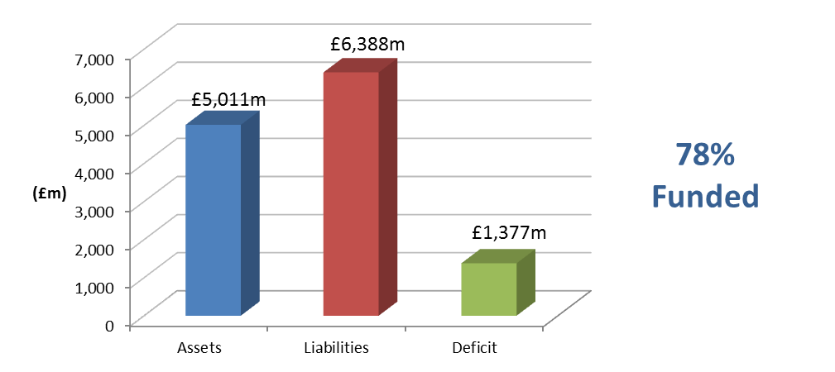

The valuation also showed that a common rate of contribution of 13.1% of pensionable pay per annum was required from employers. The common rate is calculated as being sufficient in the long term, together with contributions paid by members, to meet all liabilities arising in respect of service after the valuation date. It allows for the new LGPS benefit structure effective from 1 April 2014.

After the valuation date, there were significant changes in financial markets. In particular there was an increase in gilt yields, which underpin the liability assessment. This improved the funding position materially to 82% with a resulting deficit of £1,088 million. This improvement was taken into account when setting the deficit contribution requirements for employers where required to stabilise contribution rates. On average across the Fund, the updated deficit would be eliminated by a contribution addition of £65m per annum increasing at 4.1% per annum (equivalent to 7.6% of projected Pensionable Pay at the valuation date) for 19 years if all assumptions are borne out in practice.

Further details regarding the results of the valuation are contained in the formal report on the actuarial valuation dated March 2014.

In practice, each individual employer’s position is assessed separately and the contributions required are set out in the report. In addition to the certified contribution rates, payments to cover additional liabilities arising from early retirements (other than ill-health retirements) will be made to the Fund by the employers.

The funding plan adopted in assessing the contributions for each individual employer is in accordance with the Funding Strategy Statement (FSS). Any different approaches adopted, e.g. with regard to the implementation of contribution increases and deficit recovery periods, are as determined through the FSS consultation process.

The valuation was carried out using the projected unit actuarial method and the main actuarial assumptions used for assessing the Funding Target and the common contribution rate were as follows:

|  | For past service liabilities (Funding Target) | For future service liabilities (Common Contribution Rate) |
| --- | --- | --- |
| Rate of return on investments (discount rate) | 4.8% per annum | 5.6% per annum |
| Rate of pay increases (long term)* | 4.1% per annum | 4.1% per annum |
| Rate of increases in pensions  in payment (in excess of  Guaranteed Minimum Pension) | 2.6% per annum | 2.6% per annum |

* allowance was also made for short-term public sector pay restraint over a 3 year period.

The assets were assessed at market value.

The next triennial actuarial valuation of the Fund is due as at 31 March 2016. Based on the results of that valuation, the contribution rates payable by the individual employers will be revised with effect from 1 April 2017.

1. **Actuarial Present Value of Promised Retirement Benefits**

IAS 26 requires the present value of the Fund’s promised retirement benefits to be disclosed, and for this purpose the actuarial assumptions and methodology used should be based on IAS 19 rather than the assumptions and methodology used for funding purposes.

To assess the value of the benefits on this basis, we have used the following financial assumptions as at 31 March 2014 (the 31 March 2013 assumptions are included for comparison):

|  | 31 March 2013 | 31 March 2014 |
| --- | --- | --- |
| Rate of return on investments (discount rate) | 4.2% per annum | 4.5% per annum |
| Rate of pay increases | 4.4% per annum | 3.9% per annum* |
| Rate of increases in pensions  in payment (in excess of  Guaranteed Minimum Pension) | 2.4% per annum | 2.4% per annum |

* includes a corresponding allowance to that made in the actuarial valuation for short-term public sector pay restraint.

The demographic assumptions are the same as those used for funding purposes. Full details of these assumptions are set out in the formal report on the actuarial valuation dated March 2014.

During the year, corporate bond yields increased, resulting in a higher discount rate being used for IAS26 purposes at the year-end than at the beginning of the year (4.5% p.a. versus 4.2% p.a.). The pay increase assumption at the year-end has also changed to allow for a short-term public sector pay restraint as detailed in the actuarial valuation alongside a reduction in the long-term rate of real pay growth (1.5% p.a. versus 2.0% p.a.).

The value of the Fund’s promised retirement benefits for the purposes of IAS26 as at 31 March 2013 was estimated as £7,373 million. The effect of the changes in actuarial assumptions between 31 March 2013 and 31 March 2014 as described above is to decrease the liabilities by *c*£614 million. Adding interest over the year increases the liabilities by

c£310million, and allowing for net benefits accrued/paid over the period increases the liabilities by another *c£*33 million (including any increase in liabilities arising as a result of early retirements/augmentations). Finally, allowing for actual vs expected membership experience, which emerged at the 2013 valuation, gives a reduction in liabilities of c£185 million.

The net effect of all the above is that the estimated total value of the Fund’s promised retirement benefits as at 31 March 2014 is £6,917 million.

1. **Events after the balance sheet date**

Greater Manchester Pension Fund has been chosen by the Ministry of Justice to administer the Local Government Pension Scheme in respect of the National Probation Service and Community Rehabilitation Companies with effect from 1st June 2014. Active and deferred members of Lancashire County Pension Fund who are affected by this change transferred to the Greater Manchester Pension Fund on 1st June 2014. Probation Service pensioners who are currently members of the Lancashire County Pension Fund are scheduled to transfer out to Greater Manchester Pension Fund at the end of September 2014. The transfer share of assets is expected to be in the region of £85m and the share of liabilities of the order of £109m.

1. **Actuarial Valuation**

An actuarial valuation of the Fund is carried out every three years by the Fund’s actuary Mercer. The most recent valuation carried out was at 31 March 2010 which determines contribution rates effective from 1 April 2011 to 31 March 2014.

The Funding objective is to achieve and then maintain assets equal to the Funding Target. The Funding Target is the present value of 100% of projective accrued liabilities, including allowance for projected final pay. This is to comply with the requirements of the LGPS regulations to secure the solvency of the Fund and is in accordance with the Funding Strategy Statement. The methodology and assumptions by which the Funding Targets and contribution rates are calculated have also been determined in accordance with the Funding Strategy Statement.

The Funding Strategy Statement specifies a maximum period for achieving full funding of 19 years, this compares to a maximum period of 22 years adopted at the 2007 valuation in accordance with the then published FSS. The maximum deficit recovery period is now three years shorter so that the same target date for achieving full funding is being maintained as at the 2007 valuation. The FSS also specifies any transitional arrangements ("phasing") for the implementation of revised employer contribution requirements.

The valuation (effective from 1 April 2011) revealed a funding level of 80% and an average employer’s contribution rate of 19.1%. There have been a number of material developments which have impacted on the fund since the previous valuation in 2007. The introduction of an Inflation Risk Premium (IRP) into the determination of the pension increase assumption used for the valuation has offset the adverse impact of the fall in real yields since the 2007 valuation. The effect of the IRP in conjunction with the change from RPI to CPI indexation more than offsets the negative impact of the yields change. Revisions of the assumptions adopted for the 2010 valuation has overall acted to place a lower value on liabilities and has therefore improved the funding position.

An extract from the certified Actuarial Valuation produced by Mercer as at 31 March 2010, detailing the breakdown of the 80% funding level is as follows:

# Funding results – Funding Target

The market value of the Fund’s assets at the valuation date is compared with the value of the Fund’s past service liabilities (the Funding Target) below. The funding position at the previous valuation is shown for comparison.

**31 March 2010**

**31 March 2007**

**Total**

**£4,399m**

**Total**

**£4,955m**

**84%**

**80%**

The employer contributions for 2011/2012 are based on the 2010 valuation and the recommended employer contributions for the period 1 April 2011 to 31 March 2014 are set out in the Schedule to the Rates and Adjustments of this report.

The projected unit method of valuation was used for the valuation and is in common use for funding Pension Funds in the United Kingdom. The Valuation results depend on financial and demographic assumptions and these are detailed in full in the Actuarial Valuation and at Annex 1 of the Funding Strategy Statement.

**The Rates and adjustments certified and accompanying schedule extracted from the actuarial valuation are as follows:**

Rates and Adjustments Certificate issued in accordance with Regulation 36 of the Administration Regulations

|  |  |
| --- | --- |
| **Name of Fund** | **Lancashire County Pension Fund** |

I hereby certify that, in my opinion, the common rate of employers’ contributions payable in each year of the period of three years beginning 1 April 2011 should be at the rate of 12.5 per cent of Pensionable Pay.

I hereby certify that, in my opinion, the amount of the employers’ contributions payable in each year of the period of three years beginning with 1 April 2011, as set out above, should be individually adjusted as set out in the attached schedule.

Contributions will be payable monthly in arrears with each payment normally being due by the 19th of the following month. Pensionable Pay is pay as determined under the LGPS regulations for the calculation of employee contributions.

For employers where no allowance for non ill-health early retirement costs is included in the valuation a further individual adjustment shall be applied in respect of each non-ill health early retirement occurring in the period of three years covered by this certificate. This further individual adjustment will be calculated in accordance with methods agreed from time to time between the Fund’s actuary and the Administering Authority.

The contributions set out in the attached schedule represent the minimum contribution which may be paid by each employer. Additional contributions may be paid if requested by the employer concerned.

The contributions may be varied as agreed by the Actuary and Administering Authority to reflect any changes in contribution requirements as a result of any benefit costs being insured against a third party.

**Regulation 36(8)**

Allowance for ill health retirements has been included in each employer’s contribution rate, on the basis of the method and assumptions set out in the report.

For four employers I have shown on the attached Schedule the allowance made for non-ill health early retirements over the period of three years beginning 1 April 2011 taken into account when setting this employer’s contribution rate.

No allowance for non-ill health early retirements has been made in determining the results of the valuation for other employers, on the basis that the costs arising will be met by additional contributions.



**Signature**

**Name** John Livesey

**Qualification** Fellow of the Institute of Actuaries

**Date of signing** 31 March 2011

Schedule to the Rates and Adjustments Certificate dated 31 March 2011

|  |  |  |  |  |  |  |  |  |
| --- | --- | --- | --- | --- | --- | --- | --- | --- |
|  | **2011/12** | | | **2012/13** | | **2013/14** | | **Non-ill health early retirement allowance included for the 3 years 2011/14** |
| **Employers** | **Individual Adjust-ment)**  **%** | **Total Contribu-tion Rate**  **%** | | **Individual Adjust-ment %** | **Total Contribu-tion Rate**  **%** | **Individual Adjust-ment %** | **Total Contribu-tion Rate**  **%** | **Amount £** |
| ABM Catering Ltd | 3.5 | 16.0 | | 3.5 | 16.0 | 3.5 | 16.0 |  |
| Accrington & Rossendale College | 7.1 | 19.6 | | 7.1 | 19.6 | 7.1 | 19.6 |  |
| Accrington Academy | -1.8 | 10.7 | | -1.8 | 10.7 | -1.8 | 10.7 |  |
| Alternative Futures | 1.7 | 14.2 | | 1.7 | 14.2 | 1.7 | 14.2 |  |
| Andron (City of Preston High) | -1.2 | 11.3 | | -1.2 | 11.3 | -1.2 | 11.3 |  |
| Andron (Glenburn Sports College) | 0.5 | 13.0 | | 0.5 | 13.0 | 0.5 | 13.0 |  |
| Andron (Kennington) | 0.0 | 12.5 | | 0.0 | 12.5 | 0.0 | 12.5 |  |
| Andron (Ribblesdale High) | -0.3 | 12.2 | | -0.3 | 12.2 | -0.3 | 12.2 |  |
| Arnold Schools | 5.0 | 17.5 | | 6.2 | 18.7 | 7.4 | 19.9 |  |
| Beaufort Avenue Day Care Centre | 14.0 | 26.5 | | 17.7 | 30.2 | 21.3 | 33.8 |  |
| Blackburn College | 2.9 | 15.4 | | 2.9 | 15.4 | 2.9 | 15.4 |  |
| Blackburn St Mary's College | 1.7 | 14.2 | | 1.7 | 14.2 | 1.7 | 14.2 |  |
| Blackburn with Darwen Borough Council | 3.1 | 15.6 | | 3.6 | 16.1 | 4.1 | 16.6 |  |
| Blackpool & The Fylde College | 5.0 | 17.5 | | 5.0 | 17.5 | 5.0 | 17.5 | £246,000 |
| Blackpool Airport Ltd (from July 2004) | 20.5 | 33.0 | | 24.5 | 37.0 | 27.8 | 40.3 |  |
| Blackpool Borough Council | 3.9 | 16.4 | | 4.4 | 16.9 | 4.9 | 17.4 | £697,600 |
| Blackpool Coastal Housing | -0.5 | 12.0 | | -0.5 | 12.0 | -0.5 | 12.0 |  |
| Blackpool Sixth Form College | -0.5 | 12.0 | | -0.5 | 12.0 | -0.5 | 12.0 |  |
| Blackpool Transport Services Ltd | -12.5 | 0.0 | | -12.5 | 0.0 | -12.5 | 0.0 |  |
| Blackpool Zoo (Grant Leisure) | 5.5 | 18.0 | | 7.1 | 19.6 | 8.8 | 21.3 |  |
| Blackpool, Fylde & Wyre Society for the Blind | 29.5 | 42.0 | | 32.5 | 45.0 | 35.5 | 48.0 |  |
| Bootstrap Enterprise Ltd | 0.2 | 12.7 | | 0.2 | 12.7 | 0.2 | 12.7 |  |
| Bulloughs (Highfield) | -2.0 | 10.5 | | -2.0 | 10.5 | -2.0 | 10.5 |  |
| Bulloughs (St Augustines) | 1.9 | 14.4 | | 1.9 | 14.4 | 1.9 | 14.4 |  |
| Bulloughs (St Marys) | 4.0 | 16.5 | | 4.0 | 16.5 | 4.0 | 16.5 |  |
|  | **2011/12** | | | **2012/13** | | **2013/14** | | **Non-ill health early retirement allowance included for the 3 years 2011/14** |
| **Employers** | **Individual Adjust-ment)**  **%** | | **Total Contribu-tion Rate**  **%** | **Individual Adjust-ment %** | **Total Contribu-tion Rate**  **%** | **Individual Adjust-ment %** | **Total Contribu-tion Rate**  **%** | **Amount £** |
| Burnley Borough Council | 12.5 | | 25.0 | 12.5 | 25.0 | 12.5 | 25.0 |  |
| Burnley College | 2.3 | | 14.8 | 2.3 | 14.8 | 2.3 | 14.8 |  |
| Calico Housing Ltd | 6.8 | | 19.3 | 6.8 | 19.3 | 6.8 | 19.3 |  |
| CAPITA | 12.2 | | 24.7 | 14.1 | 26.6 | 16.0 | 28.5 |  |
| Capita (Rossendale BC) | 3.1 | | 15.6 | 4.6 | 17.1 | 6.0 | 18.5 |  |
| Cardinal Newman College | 3.3 | | 15.8 | 3.3 | 15.8 | 3.3 | 15.8 |  |
| Caritas Care Ltd (was Catholic Caring Services) | 6.2 | | 18.7 | 6.2 | 18.7 | 6.2 | 18.7 |  |
| Catterall Parish Council | 2.3 | | 14.8 | 2.3 | 14.8 | 2.3 | 14.8 |  |
| Chorley Borough Council | 6.8 | | 19.3 | 7.3 | 19.8 | 7.8 | 20.3 |  |
| Chorley Community Housing | 1.6 | | 14.1 | 1.6 | 14.1 | 1.6 | 14.1 |  |
| Church Road Methodist Day Centre | 6.7 | | 19.2 | 7.0 | 19.5 | 7.3 | 19.8 |  |
| Commission for Education & Formation | 8.0 | | 20.5 | 8.0 | 20.5 | 8.0 | 20.5 |  |
| Community Council of Lancashire | 8.3 | | 20.8 | 8.3 | 20.8 | 8.3 | 20.8 |  |
| Community Gateway Association Ltd | 1.7 | | 14.2 | 2.4 | 14.9 | 3.0 | 15.5 |  |
| Connaught Environmental (Blackpool BC) | -3.9 | | 8.6 | -3.9 | 8.6 | -3.9 | 8.6 |  |
| Connaught Environmental (Blackpool Coastal Housing) | 0.5 | | 13.0 | 0.5 | 13.0 | 0.5 | 13.0 |  |
| Consultant Caterers Ltd | 2.5 | | 15.0 | 2.5 | 15.0 | 2.5 | 15.0 |  |
| Contour Housing Association | 4.1 | | 16.6 | 4.1 | 16.6 | 4.1 | 16.6 |  |
| Creative Support Ltd | 1.6 | | 14.1 | 1.6 | 14.1 | 1.6 | 14.1 |  |
| CXL Ltd | -0.6 | | 11.9 | -0.6 | 11.9 | -0.6 | 11.9 |  |
| Danfo (UK) Ltd | 172.2 | | 184.7 | 172.2 | 184.7 | 172.2 | 184.7 |  |
| Darwen Aldridge Community Academy | -1.2 | | 11.3 | -1.2 | 11.3 | -1.2 | 11.3 |  |
| E ON UK Plc | 6.2 | | 18.7 | 6.2 | 18.7 | 6.2 | 18.7 |  |
| Edge Hill University College | 1.5 | | 14.0 | 2.0 | 14.5 | 2.5 | 15.0 |  |
| Enterprise Managed Services Ltd | 1.1 | | 13.6 | 2.4 | 14.9 | 3.6 | 16.1 |  |
| Eric Wright Commercial Ltd | 5.4 | | 17.9 | 5.4 | 17.9 | 5.4 | 17.9 |  |
| Fulwood Academy | -1.3 | | 11.2 | -1.3 | 11.2 | -1.3 | 11.2 |  |
| Fylde Borough Council | 7.0 | | 19.5 | 8.3 | 20.8 | 9.5 | 22.0 |  |
| Fylde Coast YMCA (Fylde) | -2.0 | | 10.5 | -2.0 | 10.5 | -2.0 | 10.5 |  |

|  |  |  |  |  |  |  |  |
| --- | --- | --- | --- | --- | --- | --- | --- |
|  | **2011/12** | | **2012/13** | | **2013/14** | | **Non-ill health early retirement allowance included for the 3 years 2011/14** |
| **Employers** | **Individual Adjust-ment)**  **%** | **Total Contribu-tion Rate**  **%** | **Individual Adjust-ment %** | **Total Contribu-tion Rate**  **%** | **Individual Adjust-ment %** | **Total Contribu-tion Rate**  **%** | **Amount £** |
| Fylde Community Link | 4.3 | 16.8 | 4.3 | 16.8 | 4.3 | 16.8 |  |
| Galloways Society for the Blind | 32.2 | 44.7 | 32.2 | 44.7 | 32.2 | 44.7 |  |
| Garstang Town Council | -1.3 | 11.2 | -1.3 | 11.2 | -1.3 | 11.2 |  |
| Housing Pendle Ltd | 1.8 | 14.3 | 1.8 | 14.3 | 1.8 | 14.3 |  |
| Hyndburn Borough Council | 12.3 | 24.8 | 12.3 | 24.8 | 12.3 | 24.8 |  |
| Hyndburn Homes Ltd | 1.4 | 13.9 | 1.4 | 13.9 | 1.4 | 13.9 |  |
| I Care | -1.6 | 10.9 | -1.6 | 10.9 | -1.6 | 10.9 |  |
| Kirkham Grammar School | 4.1 | 16.6 | 4.6 | 17.1 | 5.1 | 17.6 |  |
| Kirkland Parish Council | 2.5 | 15.0 | 2.5 | 15.0 | 2.5 | 15.0 |  |
| Lancashire & Blackpool Tourist Board | 1.1 | 13.6 | 1.1 | 13.6 | 1.1 | 13.6 |  |
| Lancashire County Branch Unison | 8.0 | 20.5 | 8.0 | 20.5 | 8.0 | 20.5 |  |
| Lancashire County Council | 5.8 | 18.3 | 6.2 | 18.7 | 6.6 | 19.1 |  |
| Lancashire Fire & Rescue Service | 5.0 | 17.5 | 5.0 | 17.5 | 5.0 | 17.5 | £199,000 |
| Lancashire Police Authority | 2.3 | 14.8 | 2.8 | 15.3 | 3.3 | 15.8 | £450,500 |
| Lancashire Probation Committee | 6.6 | 19.1 | 6.6 | 19.1 | 6.6 | 19.1 |  |
| Lancaster & Morecambe College | 4.1 | 16.6 | 4.1 | 16.6 | 4.1 | 16.6 |  |
| Lancaster City Council | 8.1 | 20.6 | 8.1 | 20.6 | 8.1 | 20.6 |  |
| Lancaster University | 1.9 | 14.4 | 2.2 | 14.7 | 2.6 | 15.1 |  |
| Leisure in Hyndburn | 3.3 | 15.8 | 4.5 | 17.0 | 5.7 | 18.2 |  |
| Liberata | 6.0 | 18.5 | 6.0 | 18.5 | 6.0 | 18.5 |  |
| Liberata UK Ltd (Chorley) | 8.9 | 21.4 | 8.9 | 21.4 | 8.9 | 21.4 |  |
| Lytham Schools Foundation | 2.2 | 14.7 | 2.2 | 14.7 | 2.2 | 14.7 |  |
| Mellor's (formerly Wyre) | 1.7 | 14.2 | 1.7 | 14.2 | 1.7 | 14.2 |  |
| Mellor's Catering (Cardinal Newman) | 5.0 | 17.5 | 5.0 | 17.5 | 5.0 | 17.5 |  |
| Myerscough College | 0.8 | 13.3 | 1.0 | 13.5 | 1.1 | 13.6 |  |
| Nelson and Colne College | 3.3 | 15.8 | 3.3 | 15.8 | 3.3 | 15.8 |  |
| New Fylde Housing | 42.3 | 54.8 | 42.3 | 54.8 | 42.3 | 54.8 |  |
| New Progress Housing | 3.9 | 16.4 | 3.9 | 16.4 | 3.9 | 16.4 |  |

|  |  |  |  |  |  |  |  |
| --- | --- | --- | --- | --- | --- | --- | --- |
|  | **2011/12** | | **2012/13** | | **2013/14** | | **Non-ill health early retirement allowance included for the 3 years 2011/14** |
| **Employers** | **Individual Adjust-ment)**  **%** | **Total Contribu-tion Rate**  **%** | **Individual Adjust-ment %** | **Total Contribu-tion Rate**  **%** | **Individual Adjust-ment %** | **Total Contribu-tion Rate**  **%** | **Amount £** |
| NHS PCT Blackburn | 1.6 | 14.1 | 1.6 | 14.1 | 1.6 | 14.1 |  |
| NIC Services Group Ltd | 2.5 | 15.0 | 2.5 | 15.0 | 2.5 | 15.0 |  |
| North Western & North Wales Sea Fisheries Committee | 13.4 | 25.9 | 13.4 | 25.9 | 13.4 | 25.9 |  |
| Northgate Managed Services | 0.1 | 12.6 | 0.1 | 12.6 | 0.1 | 12.6 |  |
| NSL Ltd (Lancaster) | 4.5 | 17.0 | 4.5 | 17.0 | 4.5 | 17.0 |  |
| NSL Ltd (Wyre BC) | 0.6 | 13.1 | 0.6 | 13.1 | 0.6 | 13.1 |  |
| Ormerod Home Trust Ltd | 11.7 | 24.2 | 13.7 | 26.2 | 15.5 | 28.0 |  |
| Our Lady Queen of Peace (Bullough Contract Services) | 3.5 | 16.0 | 3.5 | 16.0 | 3.5 | 16.0 |  |
| Pendle Borough Council | 12.1 | 24.6 | 14.1 | 26.6 | 16.2 | 28.7 |  |
| Pendle Leisure Trust Ltd | 1.2 | 13.7 | 1.2 | 13.7 | 1.2 | 13.7 |  |
| Penwortham Town Council | 1.5 | 14.0 | 1.5 | 14.0 | 1.5 | 14.0 |  |
| Pilling Parish Council | 4.8 | 17.3 | 4.8 | 17.3 | 4.8 | 17.3 |  |
| Preston Care and Repair | 6.0 | 18.5 | 6.0 | 18.5 | 6.0 | 18.5 |  |
| Preston City Council | 5.6 | 18.1 | 6.1 | 18.6 | 6.6 | 19.1 |  |
| Preston College | 2.7 | 15.2 | 3.0 | 15.5 | 3.3 | 15.8 |  |
| Preston Council for Voluntary Services | 9.4 | 21.9 | 9.4 | 21.9 | 9.4 | 21.9 |  |
| Progress Care Housing | 3.9 | 16.4 | 3.9 | 16.4 | 3.9 | 16.4 |  |
| Progress Housing Group Ltd | 3.9 | 16.4 | 3.9 | 16.4 | 3.9 | 16.4 |  |
| Progress Recruitments | 2.9 | 15.4 | 2.9 | 15.4 | 2.9 | 15.4 |  |
| Queen Elizabeth's Grammar School | 8.3 | 20.8 | 9.3 | 21.8 | 10.3 | 22.8 |  |
| Ribble Valley Borough Council | 3.6 | 16.1 | 4.1 | 16.6 | 4.6 | 17.1 |  |
| Ribble Valley Homes | 1.8 | 14.3 | 1.8 | 14.3 | 1.8 | 14.3 |  |
| Rossendale Borough Council | 13.8 | 26.3 | 15.3 | 27.8 | 16.8 | 29.3 |  |
| Rossendale Leisure Trust | 0.2 | 12.7 | 1.2 | 13.7 | 2.1 | 14.6 |  |
| Rossendale Transport Ltd | 10.7 | 23.2 | 19.3 | 31.8 | 27.8 | 40.3 |  |
| Runshaw College | 2.6 | 15.1 | 2.9 | 15.4 | 3.2 | 15.7 |  |
| Signposts MARC Ltd | -12.5 | 0.0 | -12.5 | 0.0 | -12.5 | 0.0 |  |

|  |  |  |  |  |  |  |  |
| --- | --- | --- | --- | --- | --- | --- | --- |
|  | **2011/12** | | **2012/13** | | **2013/14** | | **Non-ill health early retirement allowance included for the 3 years 2011/14** |
| **Employers** | **Individual Adjust-ment)**  **%** | **Total Contribu-tion Rate**  **%** | **Individual Adjust-ment %** | **Total Contribu-tion Rate**  **%** | **Individual Adjust-ment %** | **Total Contribu-tion Rate**  **%** | **Amount** £ |
| Solar Facilities (Bishop Raws) | -12.5 | 0.0 | -12.5 | 0.0 | -12.5 | 0.0 |  |
| Solar Facilities (Ripley) | 8.5 | 21.0 | 8.5 | 21.0 | 8.5 | 21.0 |  |
| Solar Facilities (Seven Stars) | 3.4 | 15.9 | 3.4 | 15.9 | 3.4 | 15.9 |  |
| Solar Facilities (St Peters) | -3.0 | 9.5 | -3.0 | 9.5 | -3.0 | 9.5 |  |
| Solar Facilities (Tarelton) | 1.4 | 13.9 | 1.4 | 13.9 | 1.4 | 13.9 |  |
| South Ribble Borough Council | 6.8 | 19.3 | 7.8 | 20.3 | 8.8 | 21.3 |  |
| South Ribble Community Leisure Ltd | 10.4 | 22.9 | 10.4 | 22.9 | 10.4 | 22.9 |  |
| St Anne's on Sea Town Council | -1.4 | 11.1 | -1.4 | 11.1 | -1.4 | 11.1 |  |
| Surestart Hyndburn | -2.0 | 10.5 | -1.0 | 11.5 | -0.1 | 12.4 |  |
| Twin Valley Homes Ltd | 3.8 | 16.3 | 3.8 | 16.3 | 3.8 | 16.3 |  |
| University of Central Lancashire | 1.6 | 14.1 | 1.6 | 14.1 | 1.6 | 14.1 |  |
| University of Cumbria (was St Martins College) | 1.5 | 14.0 | 1.5 | 14.0 | 1.5 | 14.0 |  |
| Vita Lend Lease BSF ICT | 0.2 | 12.7 | 0.2 | 12.7 | 0.2 | 12.7 |  |
| Vita Lend Lease Ltd | 1.3 | 13.8 | 1.3 | 13.8 | 1.3 | 13.8 |  |
| West Lancashire Borough Council | 7.5 | 20.0 | 7.5 | 20.0 | 7.5 | 20.0 |  |
| West Lancashire Community Leisure Ltd | -0.5 | 12.0 | -0.5 | 12.0 | -0.5 | 12.0 |  |
| Whitworth Town Council | 3.6 | 16.1 | 3.6 | 16.1 | 3.6 | 16.1 |  |
| Wyre Borough Council | 12.6 | 25.1 | 12.6 | 25.1 | 12.6 | 25.1 |  |
| Wyre Housing Association | 57.8 | 70.3 | 57.8 | 70.3 | 57.8 | 70.3 |  |

**Other interested bodies with no pensionable employees**

|  |  |  |  |  |
| --- | --- | --- | --- | --- |
| **Former Employers** | **Proportion of Pension Increases to be Recharged %** |  | **Former Employers** | **Proportion of Pension Increases to be Recharged %** |
| Alzheimer's Society | See notes |  | Ex Department of Transport | 100 |
| Barnoldswick Town Council | See notes |  | Ex National Health Service | 100 |
| Blackpool & Fylde Mind Association | See notes |  | Ex National Water Council | 100 |
| Blackpool & Fylde Society for the Deaf | 100 |  | Fylde Coast Development Association | 100 |
| Blackpool Town Centre Forum Ltd | See notes |  | Lancashire South East Probation Committee | 100 |
| Bulloughs (St Albans) | See notes |  | Lancashire Valuation Tribunal | See notes |
| Burnley & Pendle Development Association | 100 |  | New Directions | See notes |
| Burton Manor Residential College | 100 |  | Preston Vision Ltd | See notes |
| Carden Croft Ltd | See notes |  | Salmesbury & Cuerdale Parish Council | See notes |
| Community Alliance (Burnley & Padiham) Ltd | See notes |  | Skelmersdale College | See notes |
| CSB Contract Services | See notes |  | Spastics Society | 100 |
| Elm House Management Committee | See notes |  |  |  |

Note:

Members of the Fund employed by Skelmersdale College have transferred to membership of the Tyne and Wear Fund, and so a bulk transfer payment will be required. Any residual funding shortfall in the LCPF after the transfer payment should then be recovered from the College.

For the remaining employers listed as "see notes" above further calculations are required in connection with them ceasing to participate in the Fund. Further details for these employers will be notified in due course.

1. **Contacts**

[**http://www.yourpensionservice.org.uk**](http://www.yourpensionservice.org.uk)

**Benefits and other Administrative Issues**

Pensions Helpdesk

Your Pension Service

PO Box 100

County Hall

Preston

PR1 0LD

Telephone: 01772 530530

E-mail: AskPensions@lancashire.gov.uk

**Pension Benefits and Administration**

Diane Lister

Head of Your Pension Service

Telephone: 01772 534827

E-mail: AskPensions@lancashire.gov.uk

**Pension Fund Accounts**

Abigail Leech

Head of Financial Accounting & Taxation

Telephone: 01772 530808

E-mail: [abigail.leech@lancashire.gov.uk](mailto:abigail.leech@lancashire.gov.uk)

**Pension Fund Investments**

Mike Jensen

Chief Investment Officer

Telephone: 01772 534742

E-mail: [mike.jensen@lancashire.gov.uk](mailto:mike.jensen@lancashire.gov.uk)

**Pension Fund Governance**

Andrew Fox

Head of Investment Compliance

Telephone: 01772 53535916

E-mail: andrew.fox@lancashire.gov.uk